CHAPTER

### 12 NUTRITION

*Animation.12.1: Nutrition*

*Source & Credit:* [*wordpress*](https://onesource4wellness.wordpress.com/tag/anti-inflammatory/)

All organisms need nutrients for the maintenance of their lives. **Nutrient** is the food or any substance that supplies the body with elements, necessary for metabolism. Certain nutrients (carbohydrates, fats and proteins) provide energy other nutrients (water, electrolytes, minerals and vitamins) are essential to the metabolic process. The sum total of all the processes involved in the taking in and utilization of elements by which growth, repair and maintenance of activities in the organism are accomplished maintenance of activities in the organism are accomplished is called **nutrition**.

Organisms can be divided into two classes on the basis of their methods of nutrition-**autotrophic** and **heterotrophic**. Autotrophic organisms can exist in an exclusively inorganic environment because they can manufacture their own organic compounds from the inorganic raw material taken from the surrounding media. This means that they produce their own sugars, lipids, proteins etc. from carbon dioxide, water and nitrates. Heterotrophic organisms are incapable of manufacturing organic compounds from simple inorganic nutrients and so they obtain organic molecules from the environment in the form of food.

#### AUTOTROPHIC NUTRITION

See chapter 6 and chapter 11

##### Mineral nutrition in plants

Generally, all autotrophic or photosynthetic organisms need carbon dioxide and water, which supply the carbon, oxygen and hydrogen. These are the predominant elements, the plant needs for the synthesis of organic molecules. There are many other elements that enter into the composition of plants. **Nitrogen** for example, is present in proteins, **phosphorus** is present in ATP, nucleic acids and many other important compounds; chlorophyll contains **magnesium** and cytochromes contain **iron**. Where does the green plant obtain these elements it needs? Obviously not from carbon dioxide and water, but the soil is the main source of these nutrients. These are essential for the growth and life of the plant. Crops fail to lourish, if grown repeatedly in the same ield unless soil is replenished with these nutrients. The farmers replace these by spreading animal manure, sewage sludge or artiicial fertilizers in measured quantities over the ield. Some chemical fertilizers that are commonly used in Pakistan are urea, super phosphates, ammonium nitrate etc.

##### Mineral Element Deiciencies

It is very diicult or not possible to ascertain the efects of individual minerals in both plants and animals. However, the deiciencies of some elements cause serious diseases showing clear symptoms. For example nitrogen deiciency in soil results in the stunted growth and strong **chlorosis** (lack of chlorophyll) particularly in older leaves. Deiciency of phosphorus causes stunted growth of roots. Soil deicient in potassium causes leaf margins yellow and brown in colour and premature death of the plant. Deiciency of magnesium results in chlorosis. Many economically important plant diseases due to mineral deiciency are now catalogued with the help of colour photography, enabling rapid diagnosis.

#### HETEROTROPHIC NUTRITION

##### METHODS OF PLANT NUTRITION

The plants generally obtain their food from the air or the water in which they grow. There are, however, some special methods of nutrition , which are described below.

##### Saprophytic Nutrition

Feeding on dead and decaying matter such as dead leaves in the soil or rotting tree trunks is called saprophytic nutrition and derives its nutrients from host plants. They produce extracellular enzymes, which digest the decaying matter and then absorb the soluble products back into their cells. Some bacteria break down the proteins of dead plants and animals and release nitrates which are taken up by the plant roots and then built into new amino acids and proteins, thus helping in nitrogen cycle.

##### Parasitic Nutrition

Feeding by living in or on other organism (host) belonging to diferent species is called parasitic nutrition. Parasites attach themselves to living things or their host, for nourishment. For obtaining nourishment from higher plant the parasite penetrates its suckers in the conducting tissue of the host. Puccinia is a parasitic fungus that destroys the wheat plant. Dodder (Cuscuta)is a lealess plant that lives as a twining parasite.

##### Symbiotic Nutrition

It is a mutual nutrition between organisms living in association with one another. These organisms belong to two diferent species. Some important examples are lichens, mycorrhiza and root nodules with nitrogen ixing bacteria. The **lichen** is made up of a fungus and alga cells. The alga makes food by photosynthesis, while the fungus supplies water and minerals and also protection against desiccation (Fig. 12.1). **Mycorrhiza** is an association between a fungus and roots of higher plants. The fungus depends upon the photosynthate of the plant. The beneit derived by mycorrhiza plant is not properly understood. However, it is known that the

Possibly the Mycorrhizal fungus plants with mycorrhiza association show better growth beneits the plant by decomposing than those without fungal partner. **Leguminous plants** organic material in the soil and have nodules on their roots, which contain nitrogen ixing providing water and minerals such as bacteria (Fig. 12.2). The bacteria live on the plant material phosphorous to plant. and ix nitrogen, converting it into nitrates, which the plant uses.

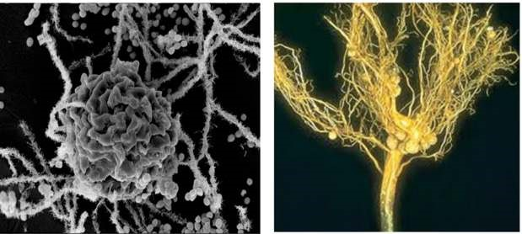

*Fig. 12.1. Lichens. Fig. 12.2. Nodules on leguminous plant roots.*

**Nutrition in insectivorous plants.** There are a few plants that supplement their inorganic diet with organic compounds. These organic compounds are obtained by trapping and digesting insects and small animals. All of the insectivorous plants are true autotrophs, but when they capture prey, their growth becomes rapid. Apparently, nitrogenous compounds of animal body are of beneit to these plants. In some plants, the trapped insects are decomposed by bacteria. In others the trapped insects are digested by enzymes secreted by the leaves. The plants absorb the nitrogenous compounds thus formed.

**Pitcher plant** (*Sarracenia pupurea*) has leaves modiied into a sac or a pitcher, partly illed with water (Fig. 12.3). The end of the leaf is modiied to form a hood, which partly covers the open mouth of the pitcher. Small insects that fall into the pitcher are prevented from climbing out by numerous stif hairs. The proteins of trapped insects are decomposed by bacteria or enzymes and the products of this decay are absorbed by the inner surface of the pitcher leaf.

**Venus-ly trap** (*Dionaea muscipula*) The leaf is bilobed with midrib between them. There is a row of long stif bristles along the margins of each lobe. When an insect touches small sensitive hairs on the surface of the leaf, the lobes quickly come together with their bristles interlocked. The trapped insect is then digested by the enzymes secreted from the glands on the leaf surface and the products are then absorbed (Fig. 12.4).

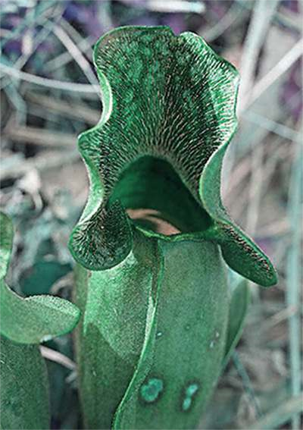

*Fig.12.3 Pitcher plant (Saracenia pupurea). several fruit lies are entrapped within the leaf.*

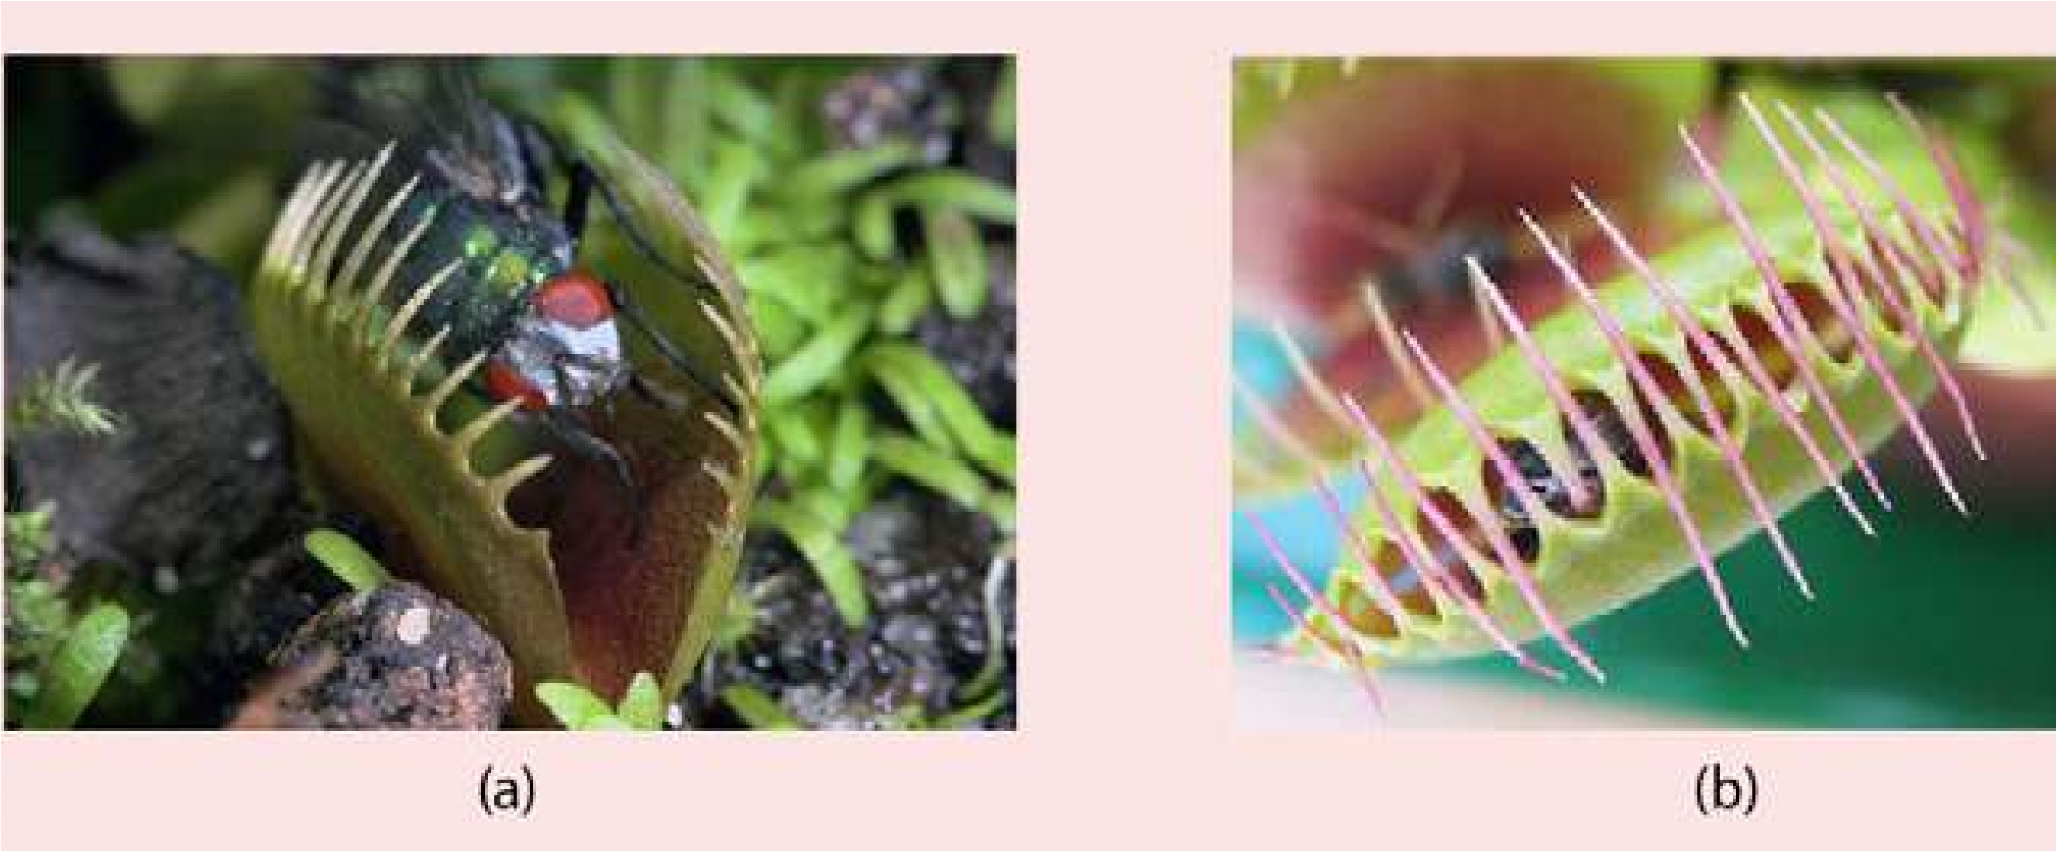

*Fig. 12.4 Leaf of Venus ly trap ( Dionaea muscipula) (a) Fly is about to trigger the hair.*

*(b) The two halves of the leaf trapping the ly.*

**Sundew** (*Drosera intermedia*) shows another type of modiication of leaf for insectivorous activity (Fig. 12.5). The tiny leaves bear numerous hair like tentacles, each with a gland at its tip. The insects, attracted by the plant’s odour are entagled. As in the above mentioned example, in sundew also the proteins of insects are digested by enzymes and the products are absorbed.

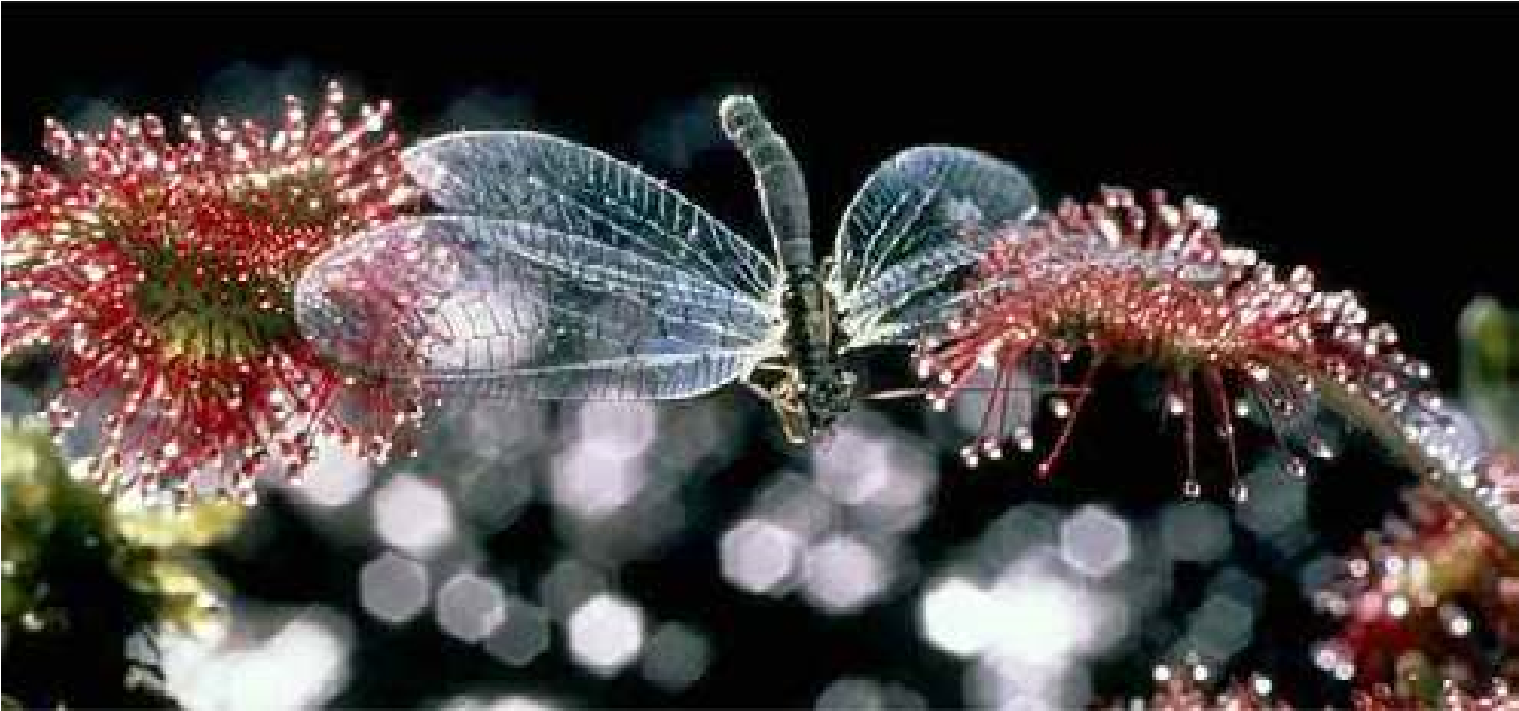

*Fig. 12.5 Leaf of Sundew (Drosera intermedia) A dragonly is caught in the sticky luid on the ends on the leaf of the glandular hair.*

###### Methods of Animal Nutrition

In large animals, every cell of the body needs nourishment, yet most cells cannot leave their position in the body and travel to a food source, so the food must be delivered. The digestive system provides the body with water, electrolytes, and other nutrients. To do this, digestive system is specialized to ingest food; propel it through the digestive tract; digest the food; and absorb water; electrolytes and other nutrients from the lumen of the digestive tract. Undigested matter from the food is moved out of the digestive tract.

Animals exhibit more variety of nutrition as compared to the plants. On the basis of nutrition animals may be classiied as:

**Detritivores:** The animals which feed on detritus (organic debris from decomposing plants and animals) are called detritivores. Earthworm is the common example of detritus feeder. It ingests fragments of decaying organic matter especially vegetation either at the soil surface or during burrowing activity.

**Herbivores:** Animals that feed on plants are called herbivores. Typical herbivores include insects, reptiles, birds and mammals. Two important groups of herbivorous mammals are rodents and ungulates. The later are hoofed grazing animals, such as horses, cattle and sheep. In herbivorous mammals the premolars and molars have large grinding surfaces. There is a large gap between the incisors and premolars. Canines are missing. In grazing and browsing herbivores, i.e. deer and sheep, there are no upper incisors.

**Carnivores:** Animals which feed on other animals are called carnivores. They have large canine teeth for catching and tearing the prey. Incisors , premolars and molars are all adapted for cutting lesh, cracking bones and reducing the chunks to sizes suitable for swallowing. Cats, dogs, lions and tigers are common examples of carnivores. A *The predator-prey interaction helps in maintaining* predator is an animal, which captures and readily *ecosystem stable. A species in the area without its naturalpredator leads to disastrous results. The introduction of* kills live animal for its food. The animal, which is *rabbits into Australia without the predator multiplied to* eaten, is the prey. *enormous number and proved a menace to the farmers.*

**Omnivores:** These are the animals which eat both plant and animal food. Example of omnivores are crows, rats, red fox, bears, pigs and man. They have the teeth structurally and functionally intermediate between the extremes of specialization attained by the teeth of herbivores and carnivores.

**Filter feeders:** Many aquatic animals ilter the water and digest the particles that they extract from it.

A common mussel possesses two large gills covered with cilia. The movement of cilia causes a current of water to enter animal via an inhalent siphon (Fig. 12.6). The water, which enters, contains the food, such as microscopic algae and protozoa. Secretory cells scattered among cilia produce sticky mucus which entangles food particles. The trapped food particles are then swept towards the mouth by the ciliary movement. Certain types of whales are also ilter feeder.

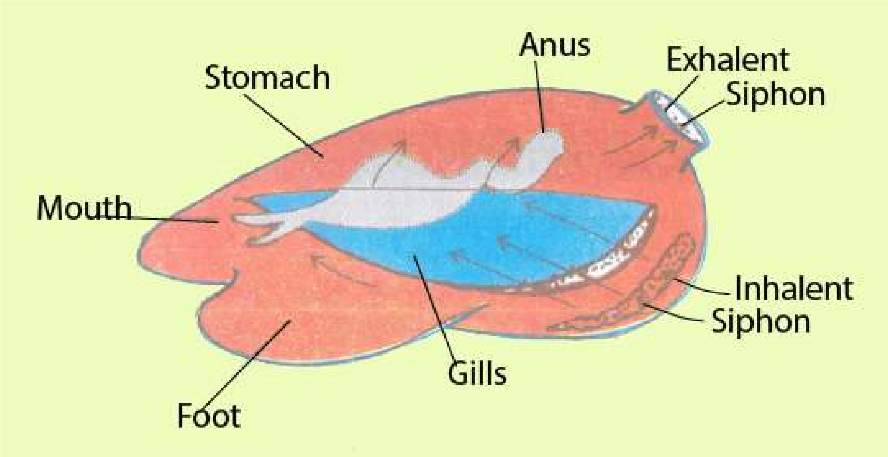

*Fig. 12.6 Filter feeding in mussel*

**Fluid feeders:** When the food is ingested in liquid form the animals are classed as luid feeders. Aphids and mosquitoes are the examples. Aphids suck the phloem juices out of the green stems by inserting their delicate stylets. The female mosquito is also a luid feeder because it sucks blood from the skin capillaries by piercing the skin with the help of tubular mouth parts.

**Macrophagous feeders:** Animals, which take in food in the form of large pieces, are macrophagous feeders. Tentacular feeding, scraping and seizing prey are the common methods of macrophagous feeding. Feeding in Hydra is the example of tentacular feeding.

Scraping type of feeding occurs in the garden snail (Helix). It feeds by using rasping organ, the radula. Leaves are held by the lips of the snail. The radula moves back and forth over the leaves with its teeth scraping the food. In this way tiny fragments of leaves are obtained which are gradually pushed backward towards the pharynx. Seizing and swallowing type of macrophagous feeding is found in spotted dogish.

###### Parasitic Nutrition

A **parasite** is an organism that lives upon or within another organism, called the host, for obtaining its food. A parasite that lives upon the host is an ectoparasite and that which lives within the host is an **endoparasite**. If an organism lives parasitically at all times, it is said to be an **obligate parasite. Facultative parasites** are capable of living independently of its host at times.

Flea and lice are ectoparasites that live in the fur or feafhers of mammals and birds and suck blood from their skin. Ticks and mites are common ectoparasites in non-human mammals. In plants, aphid is a parasite that sucks food from leaves or stems.

Leech is another common example of ectoparasite attacking both aquatic and terrestrial animals.

Endoparasites also occur in both aquatic and terrestrial animals. These parasites are most commonly found in the intestine of vertebrate host, including man, where they absorb host’s digested food. *Entamoeba histolytica*, tape worm and round worms are common examples of endoparasites. In certain cases the host may be weakened by the presence of parasite or its metabolism may be upset by the excretory products of parasite.

##### DIGESTION AND ABSORPTION

All animals have similar requirements, although these requirements difer in detail. Animals must have the supply of water, oxygen, simple sugars, amino acids, fatty acids, vitamins and many other inorganic and organic substances. These substances, except oxygen and water, are rare in the natural environment and are not directly available to the organisms. In nature these substances are available in the form of proteins, starches, fats, vitamins and minerals. As such, these moleculesr except vitamins and minerals are of no use unless they are broken down or digested into simple molecules such as amino acids, sugars and fatty acids so that they many pass through the cell membrane and be used by the body. The characteristic processes involved in holozoic nutrition are deined as

1. **Ingestion** taking in of complex food.
2. **Digestion-** the breakdown of complex organic compounds of food into simpler difusible molecules by the action of enzymes e.g. proteins (meat, ish, eggs etc.) into amino acids. Digestion may be either **Intracellular or extracellular**. In intracellular, break down of food occurs within the cells. In extracellular digestion, enzymes are secreted outside the cell into the gut cavity or lumen where then digestion takes place.
3. **Absorption** is the uptake of the difusible food molecules from the digestive region across the membrane in to the cell or into the blood stream.
4. **Assimilation** is the utilization of the products of digestion for production of energy or synthesis of cellular material.
5. **Egestionis** the elimination of undigested matter from the body.

*Animation 12.2: Digestion and Absorption*

*Source and Credit:*

*infogr.a*

[*m*](https://infogr.am/the-biology-and-chemistry-of-digestion)

###### Digestion in Amoeba

*Amoeba proteus* has intracellular mode of digestion and feeds on many kinds of tiny organisms which live with it in fresh water ponds and shallow lakes. *Amoeba* also feeds on particulate organic matter. Food may be ingested at any points on the surface of the body. When *Amoeba* comes in contact with food particle, it immediately puts out pseudopodia around it. These pseudopodia fuse together around the food particle forming the food vacuole (Fig. 12.7). If the food particle is too big, such as *Paramecium, Amoeba* encircles it, thus forming a large food vacuole. The food vacuole undergoes many changes as digestion proceeds. First it grows smaller, then larger and again smaller. Lysosomes, which contain hydrolytic enzymes, fuse with the food vacuole and enzymes are secreted into it. The irst phase of digestion is killing and softening of food that take place in the acidic medium (approximately pH 5.6) and later it becomes alkaline (about pH 7.3) during which digestion is completed. When digestion is complete in food vacuole membrane is drawn into numerous ine canals. The products of digestion are passed into the canals and inally into the surrounding cytoplasm and subsequently utilized in various metabolic reactions of the animal. Undigested matter is voided from the organism in the surrounding water by egestion at any point of its surface (Fig. 12.8).

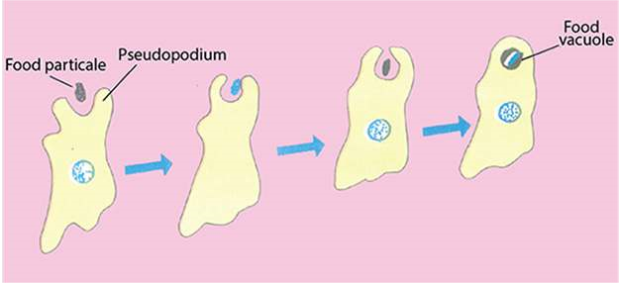

*Fig. 12.7 Amoeba ingesting food by pseudopodia*

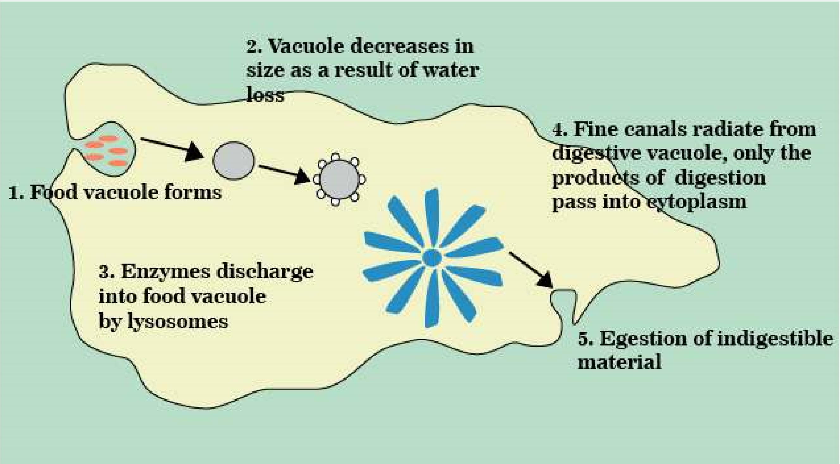

*Fig. 12.8. Ingestion, digestion and absorption in Amoeba*

###### Digestion in *Hydra*

*Hydra* is an aquatic, diploblastic cnidarian. it has vase-like body composed of two principal layers of cells. The central cavity of the body functions as a digestive cavity. The animal has only one opening to the outside called mouth which is surrounded by mobile tentacles. The digestive cavity of this sort is called gastrovascular cavity or **coelenteron** (Fig. 12.9a).

*Animation 12.3: hydra*

*Source and Credit:*

*gifsou*

[*p*](http://gifsoup.com/view/5086029/hydra-eating-its-prey.html)

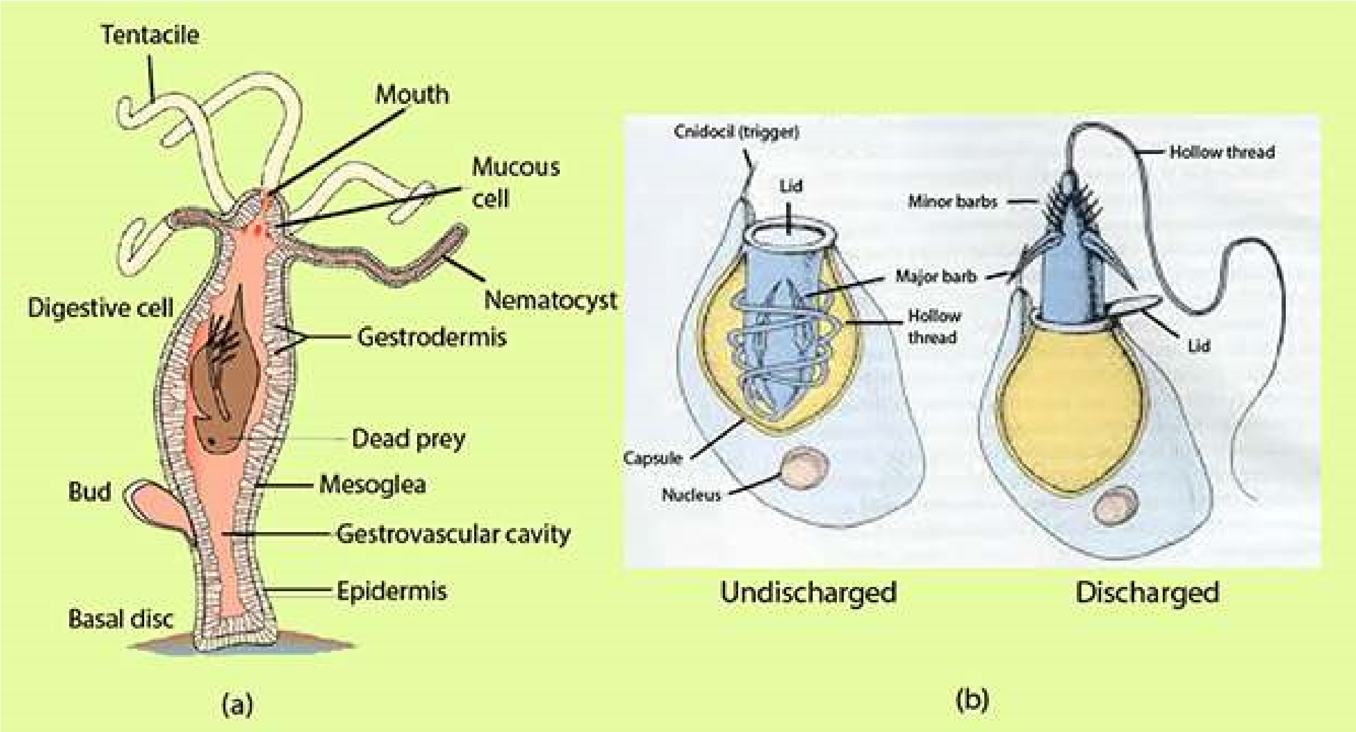

*Fig. 12.9. Hydra: (a) Longitudinal section showing the detail of wall and the gastrovascular cavity (b) neniatocysts (discharged and un-discharged)*

Embedded in the tentacles are numerous stinging cells called **nematocysts**. Each nematocyst consists of a hollow thread coiled within a capsule and a tiny hair-like trigger, projecting outside (Fig. 12.9 b).

When a prey such as *Daphnia* or *Cyclops* comes in contact with the cnidocil the hollow thread of the nematocyst turns inside out, ejects poison and the prey is paralysed or some times killed. *Hydra* then grasps its prey with its tentacles and pushes it into the digestive cavity through open mouth.

The glandular cells in the gastrodermis secrete enzymes which start extracellular digestion. Gastrodermal lagellate cells and contraction of body cavity help in mixing food with enzymes and breaking up into ine particles. These ine particles are then engulfed by phagocytic action of gastrodermal cells where digestion is completed intracellularly in the digestive vacuoles. Indigestible food is expelled out from the gastrovascular cavity via mouth. Such a digestive system is called saclike digestive system having a common opening for ingestion and egestion.

*Animation 12.4: Hydra*

*Source and Credit:*

*carnivoraforu*

[*m*](http://carnivoraforum.com/topic/10352942/1/)

Digestion in Planaria

*Planaria* is free-living, latworm found in fresh water streams and ponds. There is a single gut opening, the mouth which is located on the ventral surface near the middle of the animal. The mouth opens into a muscular tubular pharynx, which leads into the intestine. The intestine then immediately divides into three branches - an anterior one, extending forward and two lateral branches. Each of these main branches gives of numerous small branches which end blindly called caecae (Fig.

12.10).

*Animation 12.5: Planaria*

*Source and Credit:*

*gifsou*

[*p*](http://gifsoup.com/view/5324400/planaria.html)

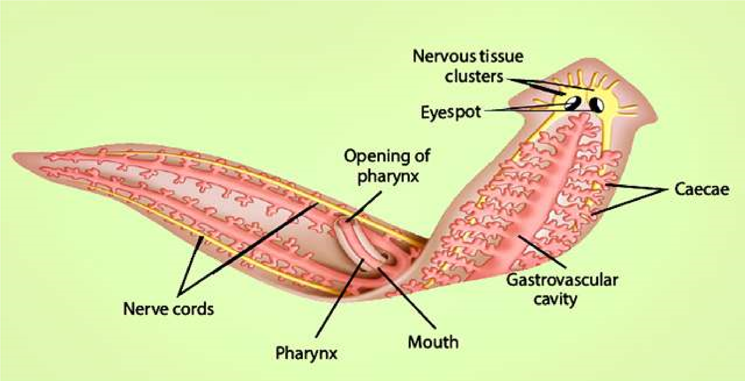

*Fig. 12.10. Planaria showing much branched gastrovascular cavity and extruded pharynx.*

*Planaria* engulfs the prey by protruding eversible pharynx through the mouth and pushes it into the gastrovascular cavity. Food is then digested in the intestine. Enzymes are secreted by the gland cells of the intestine and continue the process of extracellular digestion. Small particles of food are inally engulfed by phagocytic cells. Digestion is completed intracellularly, from where the products of digestion pass to the rest of the body ,by the process of difusion. Branched intestine also facilitates difusion of materials in to body cells. Undigested food is egested through the mouth.

###### Digestion in Cockroach

The digestive system of cockroach is of tubular type. It can be divided into fore, mid and hind gut. The foregut includes mouth cavity, pharynx, crop and gizzard. A pair of salivary glands is present in the thorax region of the animal. They secrete saliva, which is poured into the mouth cavity. The mid gut is a short narrow tube called **mesenteron stomach**. Short inger like hollow tubes, the **hepatic caecae** open into the anterior end of the midgut.

The hind gut is a long coiled tube, the terminal part of which is a thick walled chamber, the **rectum**, which opens to the exterior through anus (Fig. 12.11).

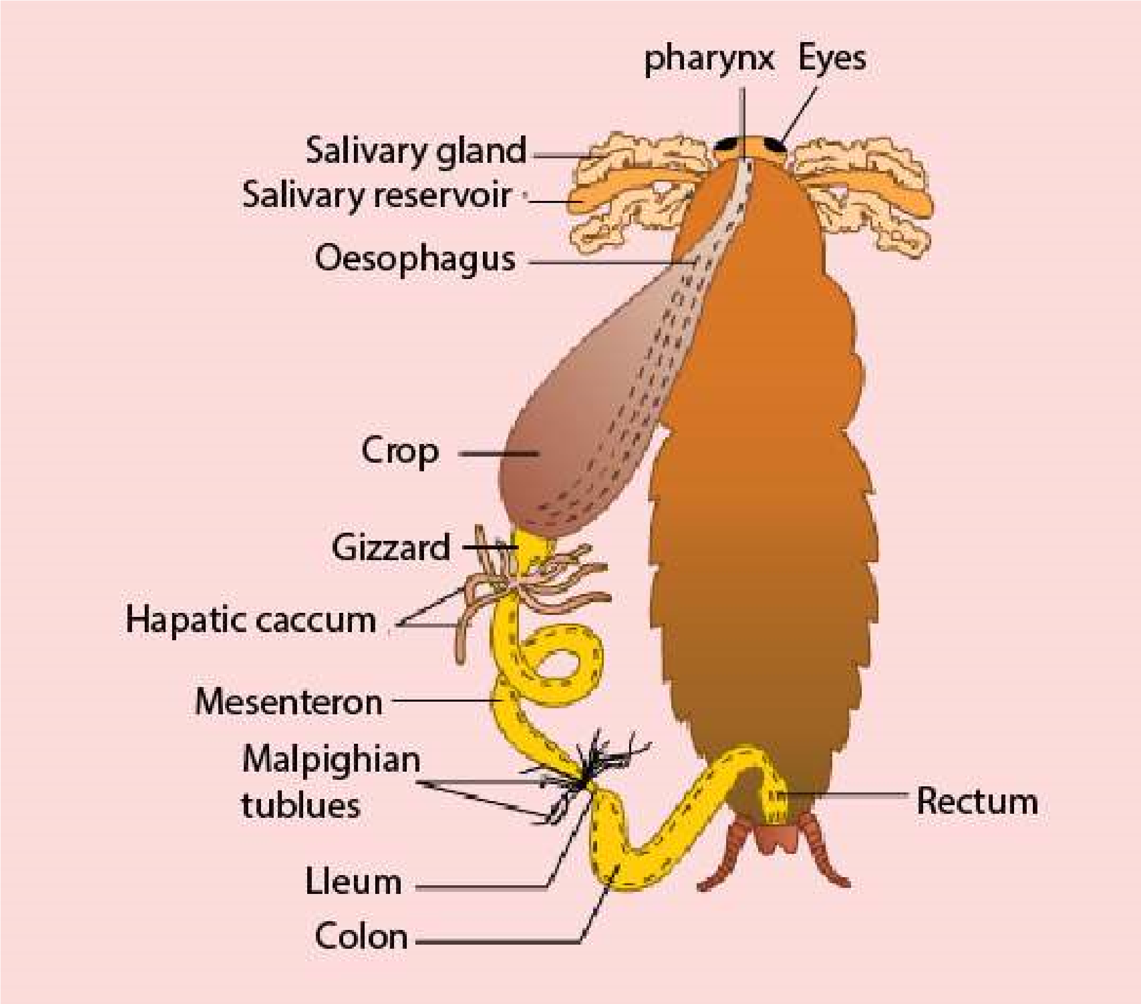

*Fig. 12.11. Cockroach digestive system*

The cockroach feeds on all types of food. After cutting the food into small pieces with the help of mandibles, it is mixed up with saliva in the mouth cavity. The digestive enzymes of saliva hydrolyse the starchy matter contained in food. The partly digested food is stored in the **crop**. Food leaves the crop chunk by chunk and after being ground in the **gizzard** it moves into the midgut. The enzymatic secretions of hepatic caecae and midgut digest the food completely. The indigestible food after temporary storage in the **rectum**, as fecal matter is then egested out through anus.

Cockroach has a tubular digestive system having mouth for ingestion and anus or cloacal aperture for egestion. It is more eicient system than sac like digestive system having specialized organs or partitions for eicient digestion and absorption of food.

*Animation 12.6: Cockroach*

*Source and Credit:*

*tumbl*

[*r*](https://www.tumblr.com/search/cockroach%20gif)

Digestion in Man

The **digestive system** of man consists of a long coiled tube that extends from the mouth to the anus. The main parts in the direction of passage of food, are the **oral or buccal cavity, esophagus, stomach,** small intestine **(duodenum, jejunum and ileum), large intestine (ascending colon, transverse colon, descending colon, caecum** and **rectum).** (Fig. 12.12) Associated with the various regions are the glands, especially **salivary glands, liver** and **pancreas**. There are three sites of digestion in the digestive system of man - oral cavity, stomach and small intestine.

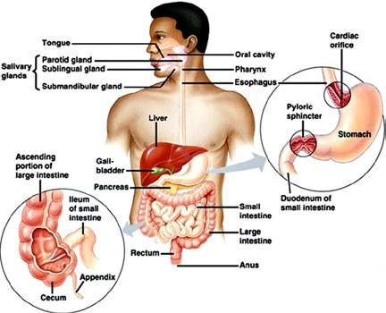

*Fig. 12.12 The digestive system of man.*

**Digestion in Oral Cavity** There are several functions of the oral cavity, the most obvious being the (a) selection of food, (b) grinding or mastication (c) lubrication and (d) digestion.

**Selection of food:** When food enters the oral cavity (the cavity bounded by palate, tongue, teeth and cheeks) it is tasted, smelled and felt. If the taste or smell is unpleasant or if hard objects like bone or dirt are present in the food, it is rejected. Oral cavity is aided in selection by the senses of smell, taste and sight. Tongue being sensory and muscular organ plays the most important role in selection of food through its taste buds.

**Grinding or mastication:** After selection, the food is ground by means of molar teeth into smaller pieces. This is useful because : (a) the esophagus allows relatively small pieces to pass through and (b) small pieces have much more surface for the enzyme to attack.

**Lubrication and digestion:** These are the main functions of the oral cavity accomplished by saliva. Saliva is secreted by three pairs of **salivary glands** namely **sublingual** glands situated below the tongue; **submaxillary** glands behind the jaws and **parotid glands** in front of the ears. Saliva produced by these glands contains three important ingredients.

i) Water and mucus, ii) Sodium bicarbonate and some other salts, iii) Carbohydrate digesting enzymes, **amylase or ptyalin.**

Water and mucus together make a slimy liquid which serves to moisten and lubricate the food so that it can be chewed eiciently and passed through the esophagus smoothly.

Sodium bicarbonate and some other salts are slightly antiseptic but their main function is to stablilze the pH of food. Fresh saliva is alkaline with a pH nearly 8, quickly loses carbon dioxide and gets to pH 6. Ptyalin is a carbohydrate - digesting enzyme, which digests starch and glycogen to maltose.

**Swallowing:** As a result of mastication, the softened, partly digested, slimy food mass is rolled into small oval lump called **bolus**, which is then pushed to the back of the mouth by the action of tongue and muscles of phaynx which ensure that the food does not enter the windpipe. Following are the events which occur during swallowing:

1. the tongue moves upwards and backwards against the roof of the mouth, forcing the bolus to the back of the mouth cavity.
2. The backward movement of the tongue pushes the soft palate up and closes the nasal opening at the back. At the same time the tongue forces the epiglottis (a lap of cartilage) into more or less horizontal position thus closing the opening of the windpipe (the glottis).

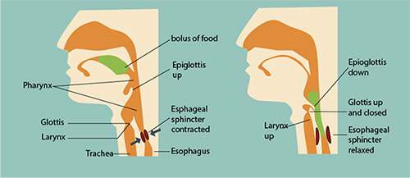

*Fig, 12.13 Swallowing in man*

1. The larynx, cartilage round the top of the windpipe moves upward under the back of the tongue.iv) The glottis is partly closed by the contraction of a ring of muscle.

v) The food does not enter the partly open glottis, because the epiglottis diverts the food mass to one side of the opening and safely down the esophagus. The beginning of the swallowing action is voluntary, but once the food reaches the back of the mouth, swallowing becomes automatic. The food is then forced down the esophagus by peristalsis (Fig. 12.13).

**Peristalsis** These are characteristic movements of the digestive tract by which food is moved along the cavity of the canal. It consists of the wave of contraction of the circular and **longitudinal** muscles preceded by the wave of relaxation thus squeezing the food down along the canal. Peristalsis starts just behind the mass of food from the buccal cavity along the esophagus to the stomach and then along the whole alimentary canal (Fig. 12.14). Occasionally, the movements are reversed, with the result food may be passed from the intestine back into the stomach and even into the mouth. This movement is called **antiperistalsis,** leading to vomiting. Hunger contractions are peristaltic contractions which are increased by low blood glucose levels and are suiciently strong to create an uncomfortable sensation often called a “hunger pang”. Hunger pangs usually begin 12 to 24 hours after the previous meal or in less time for some people.

*Fig. 12.14 Diferent stages of*

*peristaltic movement in the*

*esophagus.*

*Gravity assist the movement of*

*material through the esophagus,*

*especially*

*when*

*liquids*

*are*

*swallowed. However, the peristaltic*

*contractions that move material*

*through*

*the*

*esophagus*

*are*

*suiciently forceful to allow a*

*person to swallow, even while doin*

*g*

*a headstand.*

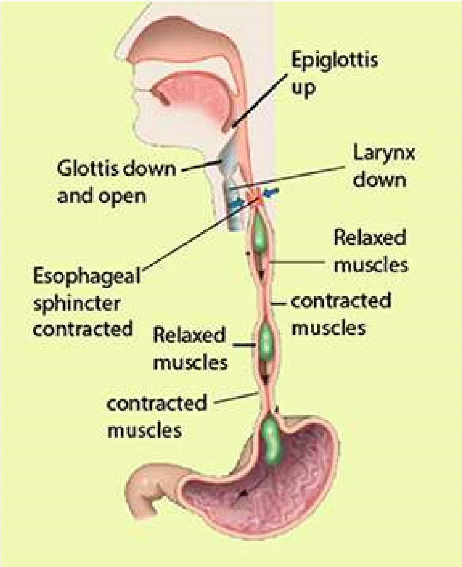

###### Digestion in stomach

At the junction between esophagus and the stomach there is a special ring of muscles called **cardiac sphincter**. When the sphincter muscles contract, the entrance to the stomach closes and thus prevents the contents of the stomach from moving back into the esophagus (Fig. 12.15a). It opens when a wave of peristalsis coming down the esophagus reaches it.

The stomach is situated below the diaphragm on the left side of the abdominal cavity. It is an elastic muscular bag that stores food from meals for some time, making discontinuous feeding possible. It also partly digests the food.

**Heart burn**

*, or*

**Pyrosis**

*, is a*

*painful burning sensation in the*

*chest usually associated with the*

*back lush of acidic chyme into*

*the esophagus. This is due to*

*overeating, eating fatty food, lying*

*down immediately after a meal,*

*consuming*

*too*

*much*

*alcohol,*

*cafeine or smoking.*

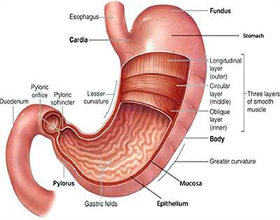

*Fig. 12.15 (a) Sagittal section of human stomach showing internal ridges and sphincters.*

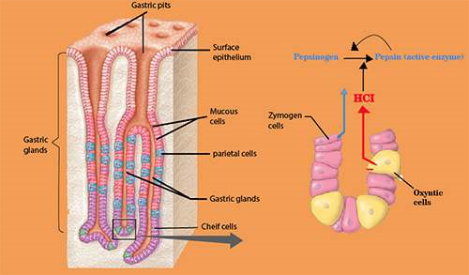

*(b) Section through stomach wall (c) Detail of gastric gland in the stomach wall*

*Animation 12.7: Stomach Digestion*

*Source and Credit:*

*gifsou*

[*p*](http://gifsoup.com/view/4269023/stomach-digestion.html)

The stomach wall is composed of three principal layers: an outer layer of connective tissue; middle layer of smooth muscles and inner layer (mucosa) of connective tissue with many glands. The middle layer of muscles consists of outer longitudinal and inner circular muscles (Fig. 12.15 b). These muscular layers help in churning and mixing the food with the stomach secretions. The mucosa of the stomach possesses numerous tubular gastric glands,which are composed of three kinds of cells;

a) **mucous cells,** that secrete mucus, b) **parietal or oxyntic** *If more protein is present in the food it stimulates* **cells** secrete hydrochloric acid and c) **zymogen cells,** *the production of gastrin hormone from the gastric* which secrete **pepsinogen** (Fig. 12.15c). The secretion *endocrine lining, which is carried by blood to thegastric glands and stimulates them to produce* of all these cells is collectively called **gastric juice.** The *more gastric juice. Thus more proteins more* secretion of the gastric juice is regulated by smell, sight *gastrin and more gastric juice for digestion.* and quality of food.

Mucus is a thick secretion that covers the inside of the stomach. It prevents the underlying walls from being digested.

Hydrochloric acid is secreted in concentrated form. It adjusts the pH of stomach contents ranging from 2-3 for the pepsin to act on proteins. It also softens the food and kills many microorganisms taken in along with the food.

**Pepsin** is an enzyme secreted in an inactive form called pepsinogen. Pepsinogen is activated to pepsin when exposed to the acidic medium or to some already activated pepsin. Pepsin hydrolyzes protein to yield peptones and polypeptides.

The muscles of stomach wall thoroughly mix up the food with gastric juice and eventually convert it to semi-solid mass called **chyme.** Gradually the stomach empties into the duodenum through the relaxed pyloric sphincter.

Digestion in small intestine

Small intestine in man consists of duodenum, jejunum and ileum. Duodenum is about 20-25 cm long, which leads into jejunum and then *Hepatic and Pancreatic secretions are also stimulated by a hormone* ileum. When chyme passes from stomach *called secretin, which is produced by the intestinal mucosa on the entry* into duodenum, its acidity stimulates the *in duodenum and secretin is carried by blood to pancreas which isof acidic food from stomach. The acidity stimulates secretin production* release of secretions from pancreas, liver *stimulated to produce pancreatic juice. Secretin also inhibits gastric* and duodenal cells. *secretion.*

**Pancreas** is a large gland whose exocrine tissue secretes a juice that lows through pancreatic duct into the duodenum. Included in this juice are enzymes that digest all principal components of food i.e. carbohydrates, fats and proteins. Carbohydrate- digesting enzyme is pancreatic **amylase** also called amylopsin, which digests starch into maltose. Fat digesting enzyme is **lipase**, that hydrolyzes a small percentage of fats into fatty acids and glycerol. Like pepsin, trypsin is also secreted as inactive trypsinogen, which is activated by enterokinase, an enzyme secreted by the lining of the duodenum.

*Animation 12.8: Pancreas*

*Source and Credit:*

*gifsou*

[*p*](http://gifsoup.com/view/4989134/pancreas.html%0D)

*Animation 12.9: Digestion in small intestine*

*Source and Credit:*

*makeagi*

[*f*](http://makeagif.com/gOZP31)

**Trypsin** splits proteins into peptones and polypeptides. Pancreatic juice also contains sodium bicarbonate, which partly neutralizes the chyme coming from the stomach. This is necessary because enzymes of the pancreas do not work well in acid conditions.

**Liver** secretes bile, which may be temporarily stored in the gall bladder and released into the duodenum through the bile duct. The bile is green, watery luid. It contains no enzymes, but its green colour is due to the bile pigments, which are formed from the breakdown of hemoglobin in the liver. The bile also contains bile salts, which act on fats, and emulsiies them. It means that they break them up into small globules, which are then easily digested by water-soluble lipase.

If bile pigments are prevented from leaving digestive *The liver is easily ruptured because it is large, ixed in* tract, they may accumulate in blood, causing a *position, and fragile or it may lacerate by a broken rib.* condition known as **jaundice.** Cholesterol, secreted *Liver rupture or laceration may result in severe internalbleeding. The liver may become enlarged as a result of heart* by the liver, may precipitate in the gall bladder to *malfunctioning, hepatic cancer or may be damaged due to* produce **gall stones**, which may block release of *hepatitis or being alcoholic.* bile.

**Jejunum** is the second portion of the small intestine extending from the duodenum to the ileum. It is about 2.4 meter in length comprising about two ifth of the small intestine. Lower three ifth of the small intestine from jejunum is the ileum.

The food, which escapes undigested from the duodenum, is completely digested in the jejunum and ileum by a group of enzymes contained in the intestinal juice. The overall picture of enzymes in the human digestive system, their substrates and inal products is as follows.

|  |  |  |
| --- | --- | --- |
| **Enzymes** | **Substrates** | **Products** |
| Amino peptidase | polypeptides | dipeptides |
| Erypsin | dipeptides | amino acids |
| Lipase | fats | fatty acids and glycerol |
| Maltase | maltose | glucose |
| Lactase | lactose | glucose and galactose |

Absorption of food

As we know that small intestine consists of duodenum, jejunum and ileum. Nearly all absorption of the products of digestion takes place in the ileum. The internal surface of ileum has many folds, which exhibit velvety appearance due to the presence of numerous inger-like outgrowths called **villi** ( Fig. 12.17 a & b). Each villus is richly supplied with blood capillaries and a vessel called lacteal of lymphatic system with a covering of epithelial cells. Electron microscope reveals that these cells have countless, closely packed cylindrical processes, **microvilli** (Fig. 12.17 c). The total area of absorption becomes incredibly large due to the enfolding, villi and microvilli. Simple Sugars and amino acids are absorbed by difusion or active transport into the blood capillaries through the microvilli. Some of the fatty acids and glycerol are also absorbed into blood stream. However, a large proportion of fatty acids and glycerol enter the epithelial cells of villi, where they recombine into fats. These fats then enter the lacteals. Proteins present in lymph vessels combine with fat molecules to form lipoprotein droplets. These pass *Many humans develop intestinal gas and diarrhoea* into blood stream via thoracic lymphatic duct. The lipo- *from consuming milk product, because they lack the* proteins are subsequently hydrolysed by blood plasma *enzymes for digesting lactose in milk. The epithelial cells of villi are constantly shed into intestine. These* enzyme and enter body cells, where they may be used *cells are replaced by the new cells moving up due to* in respiration or stored as fat in the liver, muscle of *rapid cell division in crypts (Fig. 12.17)* under the skin.

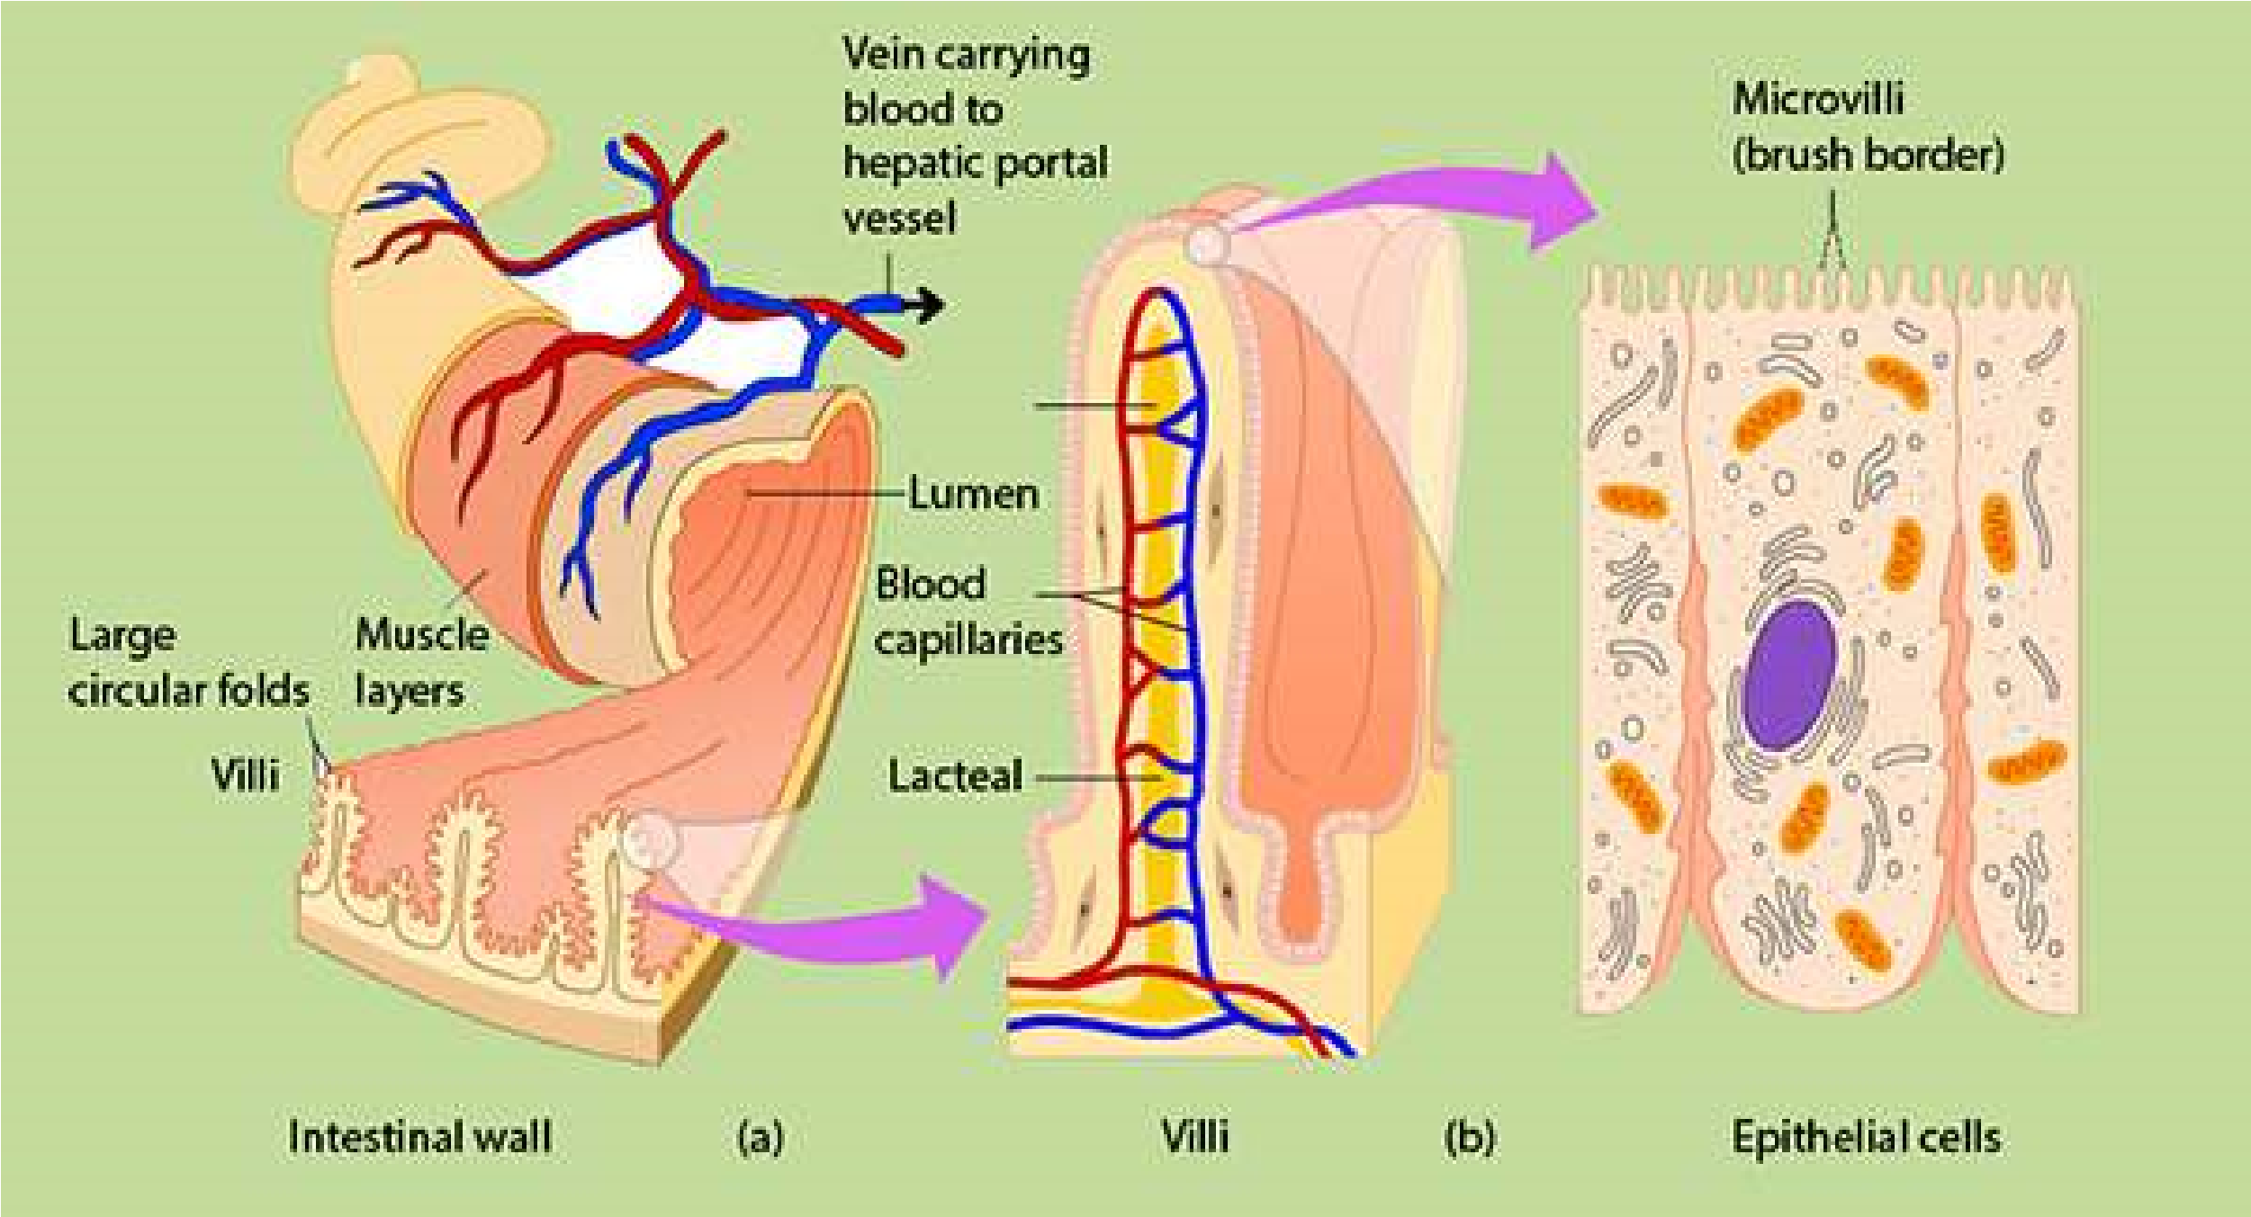

*Fig. 12.17. (a) Part of wall of small intestine showing glands and vilii.*

*(b) Detail of villus structure.*

*Animation 12.10: Digestion of food*

*Source and Credit:*

*sciproject-1-*

[*4*](http://sciproject-1-4.blogspot.com/)

*Animation 12.11: Absorption of*

*food*

*Source and Credit:*

*askiitian*

[*s*](http://www.askiitians.com/revision-notes/biology/digestion-and-absorption/)

The intestinal contents are pushed along the alimentary canal by normal peristaltic activity. At the end of ileum, there is an ileocolic sphincter that opens and closes time to time to allow a small amount of residue from the ileum to enter the large intestine.

**Large intestine :** The large intestine is composed of a caecum, colon and rectum. Caecum is a blind sac that projects from the large intestine between ileum and colon. From the blind end of the caecum there arises a inger like process called **appendix.** The appendix, some times gets inlamed due to entrapping and then puriication of food causing **appendicitis,** which has to be removed surgically in many instances.

The material that passes from the small intestine to the large intestine contains a large amount of water, dissolved salts and undigested material. Water and salts are absorbed into blood, while undigested material is rejected as feces. The fecal matter contains a large number of bacteria, plant ibers, slouged of mucosal cells, mucus, cholesterol, bile pigments and water. Large intestine also harbors a large population of useful bacteria that synthesize some vitamins especially vitamin K, which are absorbed in blood. If the absorption of water and salts does not take place due to infection, drug action or emotional disturbance, a condition known as **diarrhoea** occurs. If this condtion is unchecked, dehydration develops that may prove to be fatal. The other extreme condition is **constipation**, which is caused by the excessive absorption of water.

**Rectum** is the last part of large intestine, where feces are temporarily stored and rejected through anus, at intervals. Anus is surrounded by two sphincters, the internal is of smooth and outer of striped muscles. Under normal condtions, as the rectum is illed up with feces, it gives rise to defecation relex. This relex can be consciously inhibited in individuals other than infants. Gradually the child learns to bring this relex under control.

*Animation 12.12: large Intestine*

*Source and Credit:*

*makeagi*

[*f*](http://makeagif.com/gYNfu0)

Table 12.1 Functions of The Digestive Organs

**Function**

**Secretion**

**Organ**

**Oral Cavity**

Teeth

Lips and cheeks

Tongue

Mastication (cutting and

grinding

of

food);

communication.

Manipulation of food; hold food

in position between the teeth;

communication.

Manipulation of food; holds

food in position between the

teeth; cleansing teeth; taste

None

Saliva

from

buccal

glands

(

mucus only

).

Some mucus; small amount of

serous luid.

**Salivary Glands**

Parotid gland

Submandibular

glands

Sublingual glands

Secretion of saliva through

ducts to

*posterior portions of*

*oraI cavity.*

Secretion of saliva in loor of

oral cavity.

Secretion of saliva in loor of

oral cavity.

Saliva with amylase

Saliva, with amylase

mucus

Saliva with mucus only.

**Pharynx**

swallowing

Some mucus

**Esophagus**

Movement of food by peristalsis

from pharynx to stomach

Mucus

**Stomach**

Mucous cells

Parietal cells

Zymogen cells

Endocrine cells

Mechanical mixing of food;

enzymatic digestion; storage;

absorption.

Protection of stomach wall by

mucus production

Decrease in stomach pH.

Protein digestion.

Regulation of secretion and

motility.

Mucus

Hydrochloric acid.

Pepsinogen

Gastrin

|  |  |  |
| --- | --- | --- |
| **Accessory Glands**  Liver  Gallbladder  Pancreas | Secretion of bile into duodenum  Bile storage; absorbs water and electrolytes to concentrate bile.  Secretion of several digestive enzymes and bicarbonate ions into duodenum. | Bile  No secretions of its own, stores and concentrates bile. Trypsin, chymotrypsin, pancreatic amylase, pancreatic lipase, bicarbonate ions. |
| **Small Intestine**  Duodenal glands  Goblet cells  Absorptive cells  Endocrine cells | Protection  Protection  Secretion of digestive enzymes and absorption of digested materials.  Regulation of secretion and motility. | Mucus  Mucus  Enterokinase, amylase, peptidases, sucrase, maltase, lactase, lipase. Gastrin, secretin, |
| **Large intestine** Goblet cells | Absorption, storage, and food movement.  Protection | Mucus |

#### SOME COMMON DISEASES RELATED TO NUTRITION

##### Dyspepsia

Incomplete or imperfect digestion is called **dyspepsia**. This is not a disease in itself but symptomatic of other disorders or diseases. This is characterized by abdominal discomfort, latulence, heartburn, nausea and vomiting. These symptoms may occur irregularly and in diferent patterns from time to time. Dyspepsia may occur due to excessive acidity in stomach or faulty function of stomach and intestine or insuicient quality or quantity of bile secretions.

##### Food poisoning

This term indicates an illness from indigestion of food containing toxic substances. One of the commonest causes of food poisoning are the toxins produced by bacteria, Salmonella and Campylobacter. These bacteria live in the intestines of cattle, chicken and duck without causing disease symptoms. Humans, however, may develop food poisoning if they drink milk, eat meat or eggs which are contaminated with these bacteria. The symptoms of food poisoning are diarrhoea, vomiting and abdominal pain. They occur from 12-24 hours after eating contaminated food. Infection is most likely, if unpasteurized milk is drunk or if meat is not properly cooked.

The liquid that escapes during defrosting frozen meat contains Salmonella bacteria. The dishes and utensils while the meat is defrosting must not be allowed to come in contact with any other food.

A severe form of food poisoning is **botulism**. This is caused by toxins produced by bacteria known as *Clostridium botulinum*. Botulism develops by the use of improperly canned or otherwise preserved foods, especially meat. The toxin produced by these bacteria is very powerful and has selective action on central nervous system, causing cardiac and respiratory paralysis. The early symptoms of this diseases are fatigue, dizziness, double vision, headache, nausea, vomiting, diarrhoea and abdominal pain.

##### Obesity

It is the term employed when a person has abnormal amount of fat on the body. If one eats too much food than body requirement, the surplus is stored as fat so becomes overweight or **obese**. There is fat stored in **adipose tissue** in the abdomen, around the kidneys and under the skin. Certain cells accumulate drops of fat in their cytoplasm. As these drops increase in size and number, they join together to form one large globule of fat in the middle of the cell, pushing the cytoplasm into thin layer and the nucleus to one side. Groups of fat cells form adipose tissue. Some people never seem to get fat no matter how much they eat, while others lay down fat when their intake only just exceeds their need. The explanation probably lies in the balance of hormones which, to some extent, is determined by heredity. An obese person is much more likely to sufer from high blood pressure, heart disease, diabetes mellitus, stomach disorder than a person who has normal body weight.

##### Anorexia Nervosa

This term is employed to the loss of appetite due to the fear of becoming obese. Such a feeling is common in human females between the age of 12 and 21 years. Fear does not diminish even when weight is dropped to dangerous level. Psychiatric therapy is usually required when patient refuses to eat.

Anorexia is an illness which largely afects girls usually just after the onset of puberty. The illness is characterized by the loss of appetite due to the fear of becoming obese. An anorexic girl over estimates the size of her own body and so insists that she is over weight when in reality her weight has dropped to a dangerous level. These girls are often immature psychologically and unable to cope with the challenges of puberty and their emerging sexuality. The loss of feminine characteristics enable the girls to retreat into a child like state in which they feel safe. Psychiatric therapy is usually required to treat anorexic girls. Such patients are fed through any route other than alimentary canal that is intramuscularly or intravenously. The recovery is very slow. It may take 2-4 years and in some cases longer.

###### Bulimia Nervosa

It is neurotic disorder in slightly older girls. It is characterized by bouts of over eating fattening food such as fried food or cream cakes. This voracious eating is followed immediately by selfinduced vomiting, fasting or purgatives. The frequent vomiting and purging may cause physical efects including **serum electrolyte** imbalance and frequent recurring infections. Treatment of bulimics is likely to be prolonged. The initial treatment is to overcome the efects of weight loss and malnutrition. It is necessary to undertake the treatment in hospital under strict supervision.

###### Piles

Piles or hemorrhoids are masses of dilated, tortuous veins in the anorectal mucosa. These masses may some times start bleeding during bowel movements. Situation may aggravate when the patient sufers from constipation. The urge to defecate is depressed and it becomes diicult to expel the faeces. This may cause other symptoms of ill health because of the physical distension of therectum. The only therapy required is the improvement of the hygiene and the use of food softeners, such as roughage, in food or laxatives. The patients are advised not to sit on hard seats. Depending on severity of the symptoms, sometimes the hemorrhoids have to be removed surgically

###### Ulcer

The inner wall of digestive tract is normally covered with mucus, which protects it from enzymes. When the mucus layer breaks down the digestive enzymes begin to eat away the walls of stomach or duodenum. This results in a sore called ulcer. Occasionally, an ulcer is so severe that a hole develops in the wall of the digestive tract and the contents of the tract spill into the abdominal cavity, leading to severe infections which may prove to be fatal, if immediate medical care is not sought.

Excessive secretion of gastric acid secretion is an important factor of peptic ulcer. Smoking, spicy food, alcoholic beverages, cofee, tea and stress should be avoided by the patients sufering from ulcer.

##### EXERCISE

**Q.1 Fill in the blanks**

1. Plants absorb minerals in their _____________form, as found in the soil.
2. In plants the most common nutrient deiciencies are o f ___________ , _____________ and______________ .
3. A plant requires_____________for holding its cell together.
4. Most of the organic material in a plant is ____________ .
5. Chlorosis is usually caused by insuicient___________ .

1. In _____________the trapped insects are decomposed by bacteria.
2. The structure in the mouth that prevents food from entering the nasal cavities is the ___________ .
3. The stomach functions to __________ ana food and its________ .

(ix ) ___________ is the common example of detritivore.

1. Pancreas produces____________ which stimulates the conversion of glycogen to

______________ .

1. Vomiting occurs due to ______________ movements.

**Q.2 Short Questions**

1. What is the advantage of a digestive tract as compared with a digestive cavity?
2. What are functions of human liver?
3. What measures should be taken to avoid food poisoning?

1. Can we get along without large intestine? if not why?

**Q.3 Extensive questions**

1. Deine nutrition. Describe the role of diferent elements in plant nutrition.
2. a) Distinguish between saprophytic and parasitic modes of life, (b) i. Name one parasitic plant, ii. Describe its method of nutrition, explaining why normal nutrition is not possible.
3. What are heterotrophs? Describe diferent methods of nutrition in heterotrophs.
4. What are the advantages and disadvantages of the parasitic mode of life compared with that of a free living organism.
5. Why is digestion necessary? Describe what happens to a meal containing fats, carbohydrates and proteins while it is in the stomach of man.
6. What is holozoic nutrition? Describe the characteristics processes involved in holozoic nutrition giving the example of Amoeba.
7. How do (i) the saliva, (ii) the pancreas, (iii) the liver help in the digestion of the food of man? Draw a diagram of the digestive system to show the positions of the pancreas and the liver.
8. Make a labelled diagram of the alimentary and digestive glands in cockroach. What are the functions of the glands you sketch?
9. Describe the structure and functions of human stomach.
10. How do the digestive tract of herbivores difer from those of carnivores?
11. What prevents the wall of stomach from being digested?
12. What specialized features of your small intestine account for the eicient absorption of digested foodstufs?

1. W hat is the contribution of liver and pancreas in the process of digestion?

(xvi) How can we control obesity?

(xv) How is gastric juice production regulated?

CHAPTER

13  Gaseous

## Exchange

*Animation 13.1:* Gaseous Exchange

[*Source & Credit: Wikispaces*](http://anatomyeshs.wikispaces.com/Ch.16+Respiratory+System)

### NEED OF RESPIRATORY GAS EXCHANGE

At all levels of activities in living organisms an uninterrupted supply of energy is required. Respiration is one of the most important metabolic activities of all organisms. Respiration occurs at two levels, i.e, organismic and cellular level. Organismic respiration is also known as breathing or ventilation. The cellular respiration is directly involved in the production of energy, necessary for all living activities. Cellular respiration is the process by which cell utilizes oxygen, produces carbon dioxide, extracts and conserves the energy from food molecules in biologically useful form, such as, ATP.

**ADVANTAGES AND DISADVANTAGES OF**

### GAS EXCHANGE IN AIR AND IN WATER

Exchange of gases during organismic respiration is carried out only by difusion. Respiratory gases are exchanged between body luid and outside medium which may be water or air. There is no active transport mechanism to move respiratory gases across biological membranes. For that matter, air is better respiratory’ medium than water. Oxygen can be obtained more easily from air than from water because of many reasons.

Firstly, the oxygen content of air is much higher than the oxygen content of equal volume of water. A liter of water cannot contain even 10 ml of oxygen whereas oxygen content of fresh air is about 200 ml per liter. Secondly, oxygen difuses about 8000 times more quickly in air than in water.

Breathing or ventilation is directly involved in the exchange of gases .The ventilation of water is far more diicult than the ventilation of air, because water is 8000 times more dense than air .In terms of viscosity the water is 50 times more viscous, which makes it more diicult for exchange of gases as compared to air.

### GASEOUS EXCHANGE IN PLANTS

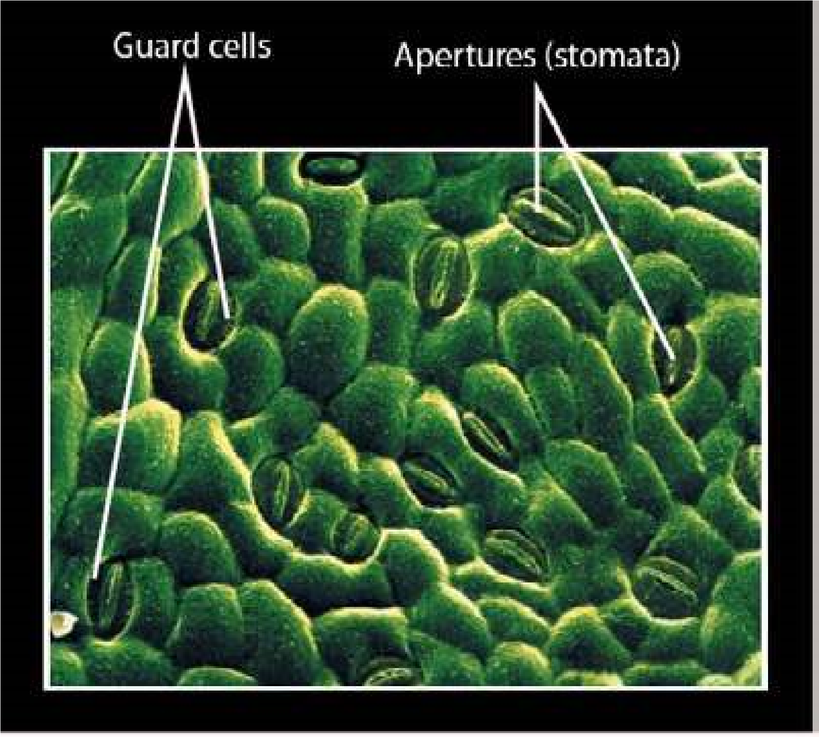Plants like animals also get their energy from respiration. In plants, in contrast to animals, no special organ or system is present for gaseous exchange as they exist in higher animals. Every cell of plant carries out exchange of gases according to its needs. The transport system of plants which includes conducting tissues i.e. xylem and phloem is not involved in the transport of gases in the plants. In most cells of mesophyll which are specialized for photosynthesis, there are present large air spaces. These air spaces are directly involved in gaseous exchange. Stomata are the main sites of exchange of gases in plants. Stomata are largely present in the leaves and in young stem. In older stems, cork tissue is present which is formed of dead cells. The cork tissue has special pores called lenticels which are involved in gaseous exchange. Land plants get their oxygen directly from air which enters through stomata. Enormous number of stomata are. present on the leaves. It is estimated that there are 12000 stomata per square centimeter of leaf surface in Tobacco plant. These stomata lead to the intercellular spaces (spaces between cells) of mesophyll tissue. The air spaces are comparable to honey comb. These air spaces may comprise up to 40% of the total volume of the leaf. The exchange of gases between and the moist surface of mesophyll cells takes place promptly (Fig 13.1). The roots of the land plants get their oxygen from the air existing in the spaces between the soil particles. Aquatic plants obtain their oxygen by difusion from dissolved oxygen in water.

*Fig. 13.1 Stomata on leaf surface*

#### Photorespiration and its Consequences

Respiratory activity which occurs in plants during daytime is called **photorespiration**. In the process of photorespiration carbon dioxide is released and oxygen is absorbed. The oxygen absorbed is not useful to produce energy such as ATP. In other words photorespiration is a light dependent process during which oxygen is absorbed and carbon dioxide is released. This oxygen is derived from the early reaction of photosynthesis.

The photorespiration is a process in which ribulose bisphosphate carboxylase/oxygenase (rubisco) ixes oxygen instead of carbon dioxide which results in lowering the overall rate of carbon dioxide ixation and plant growth.

#### Ribulose 1,5 bisphosphate (RuBP) reacts with oxygen in photorespiration

The irst step of photorespiration during which RuBP reacts with oxygen is carried out by rubisco, the most abundant protein in chloroplasts and probably the most abundant protein in the world. The rubisco is carboxylase as well as oxygenase. When rubisco acts as carboxylase it adds carbon dioxide to RuBP, which is an accepter molecule. On the other hand when rubisco is oxygenase it adds oxygen to RuBP. Both these reactions compete with each other. When RuBP reacts with oxygen, a two carbon compound glycolate is produced.

#### RuBP + O2 8 Glycolate

The glycolate thus produced difuses into the membrane bounded organelles known as **peroxisomes**. In the peroxisomes the glycolate is converted into glycine, through a series of reactions.

#### Glycolate 8glycine

The glycine is the simplest amino acid which soon after its formation difuses into the **mitochondria** where two glycine molecules are converted into serine and synthesis a molecule of carbon dioxide is formed.

##### 2 glycine 8 serine + CO2

The pathway in which RuBP is converted into serine is called photorespiration. The process of photorespiration uses ATP and NADPH produced in the light reactions just like **Calvin-Benson cycle.** But, in fact, photorespiration is reverse of Calvin cycle. During photorespiration carbon dioxide is released instead of ixation into carbohydrates. In most plants photorespiration reduces the amount of carbon ixed into -carbohydrates by 25%.

In a hot and dry day the level of oxygen inside the leaf rises. This is because the stomata close to prevent the loss of water. The level of carbon dioxide falls because it is being consumed and the level of oxygen rises because closed stomata do not let it go out.

It is interesting that apparently the photorespiration reduces the photosynthetic process and it is not essential for plants and many plants grow normally without the process of photorespiration. It is also observed that if photorespiration is inhibited chemically, the plant can, still grow. Then why does photorespiration exist? The common simple answer to this question is that the active site of rubisco is evolved to bind both carbon dioxide and oxygen together. Originally it was not a problem as there was little oxygen in the atmosphere and the carbon dioxide binding activity was the only one used. The photorespiration started when the quantity of oxygen became more.

### RESPIRATORY ORGANS IN REPRESENTATIVE AQUATIC AND TERRESTRIAL ANIMALS

#### Properties of respiratory surfaces in animals

Respiratory surfaces in animals are the sites where gaseous exchange takes place. The respiratory surfaces in most animals exhibit the following features :

1. **Large surface and moisture:**

The surface area should be extremely large and kept moist as it is seen in the lungs in the land vertebrates and in the gills in the case of ishes.

1. **Thin epithelium:**

The distance across which difusion has to take place should be little. In most animals the epithelium which separates air and blood is only two cell thick. As a result the distance for difusion is very short.

1. **Ventilation:**

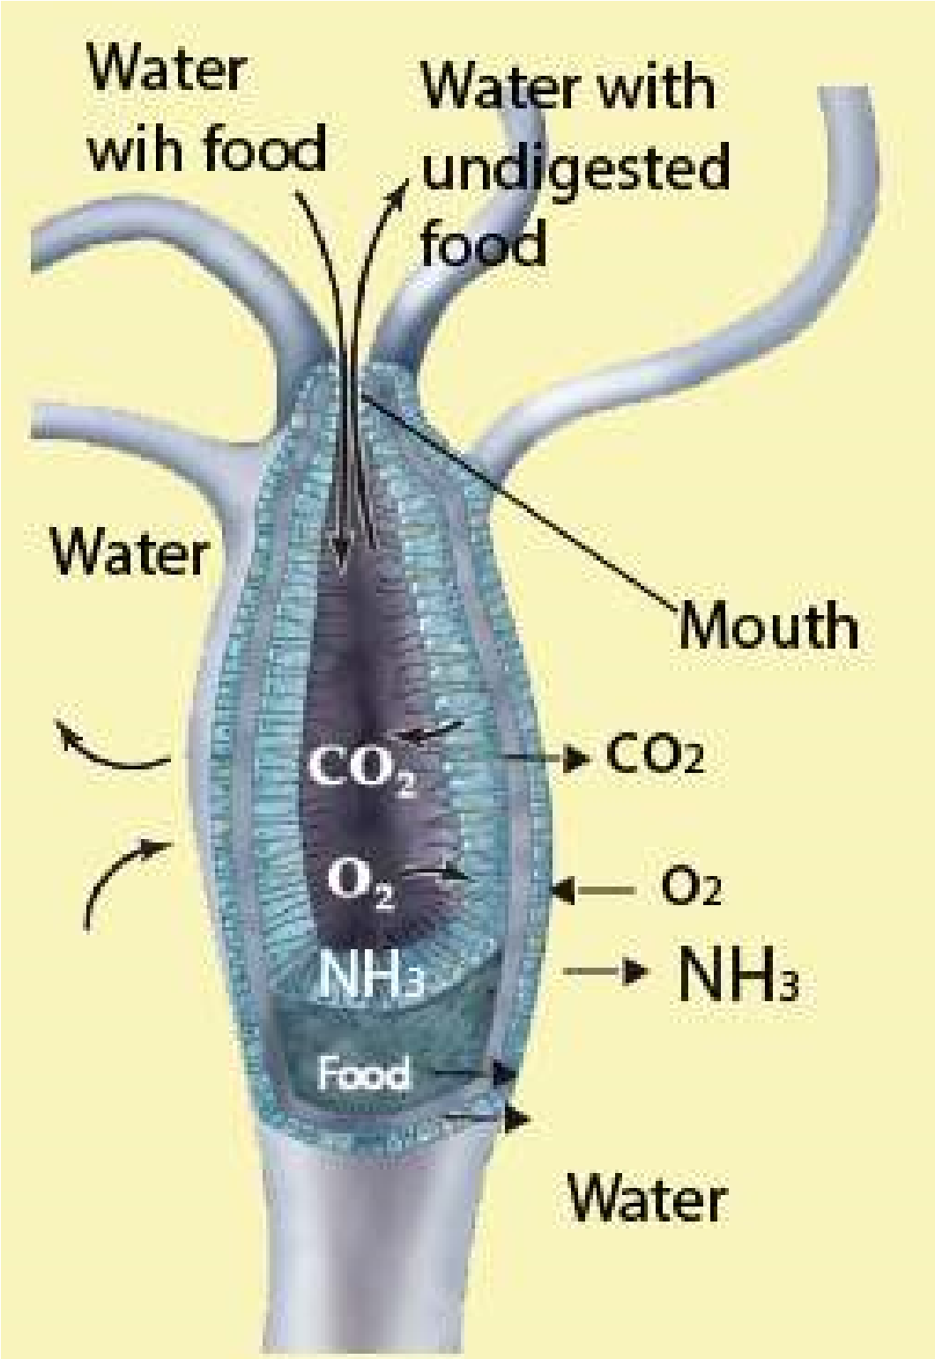Ventilation maintains a steep difusion gradient. There is a big diference in the concentration of the gases at two points which brings about difusion.

1. **Capillary network:**

The respiratory site should possess extensive network of capillaries through which blood should low all the ime at an adequate speed. In this way steep difusion gradient is maintained which helps in rapid difusion of oxygen.

#### Respiration in Hydra

Hydra has no specialized organs for respiration. Exchange of gases i.e., intake of oxygen and removal of carbon dioxide, occurs through the entire general surface in contact with water. Exchange of oxygen in and carbon dioxide out also occurs in cells lining the digestive cavity. In this way the surface lining of the enteron acts., as an eicient respiratory surface (Fig. 13.2).

*Fig 13.2 Respiration in Hydra*

*Animation 13.2: Hydra*

*Source and Credit:*

*carnivoraforu*

[*m*](http://carnivoraforum.com/topic/10352942/1/)

*Animation 13.3: hydra*

*Source and Credit:* [*gifsoup*](http://gifsoup.com/view/5086029/hydra-eating-its-prey.html)

#### Respiration in Earthworm

Although earthworm is much complex than hydra, yet it does not have any specialized respiratory organs. The exchange of gases occurs mainly through skin. Skin is richly supplied with blood capillaries and is always kept moist by the secretion of epidermal mucous gland cells and also by coelomic luid exuding out through the dorsal pores. Oxygen dissolved on the wet surface passes through the cuticle and epidermal cells into the blood. In the blood, oxygen combines with haemoglobin to form oxyhaemoglobin.Oxyhaemoglobin releases up oxygen at the tissue level. In earthworm, blood does not come into direct contact with tissue cells so oxygen must difuse through the tissue luids and coelomic luids. Carbon dioxide is removed from the tissues by the blood and carried in the plasma to skin, from where it is excreted ((Fig. 13.3)

*Animation 13.4: Respiration in Earthworm*

*Source and Credit:*

*waterwerel*

[*d*](http://www.waterwereld.nu/regenwormeng.php)

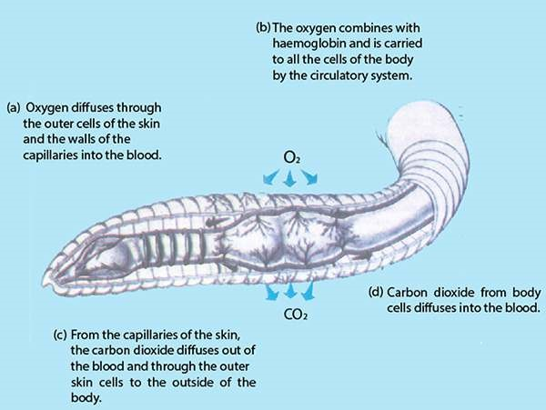

*Fig. 13.3 Respiration in Earthworm*

#### RESPIRATION IN COCKROACH

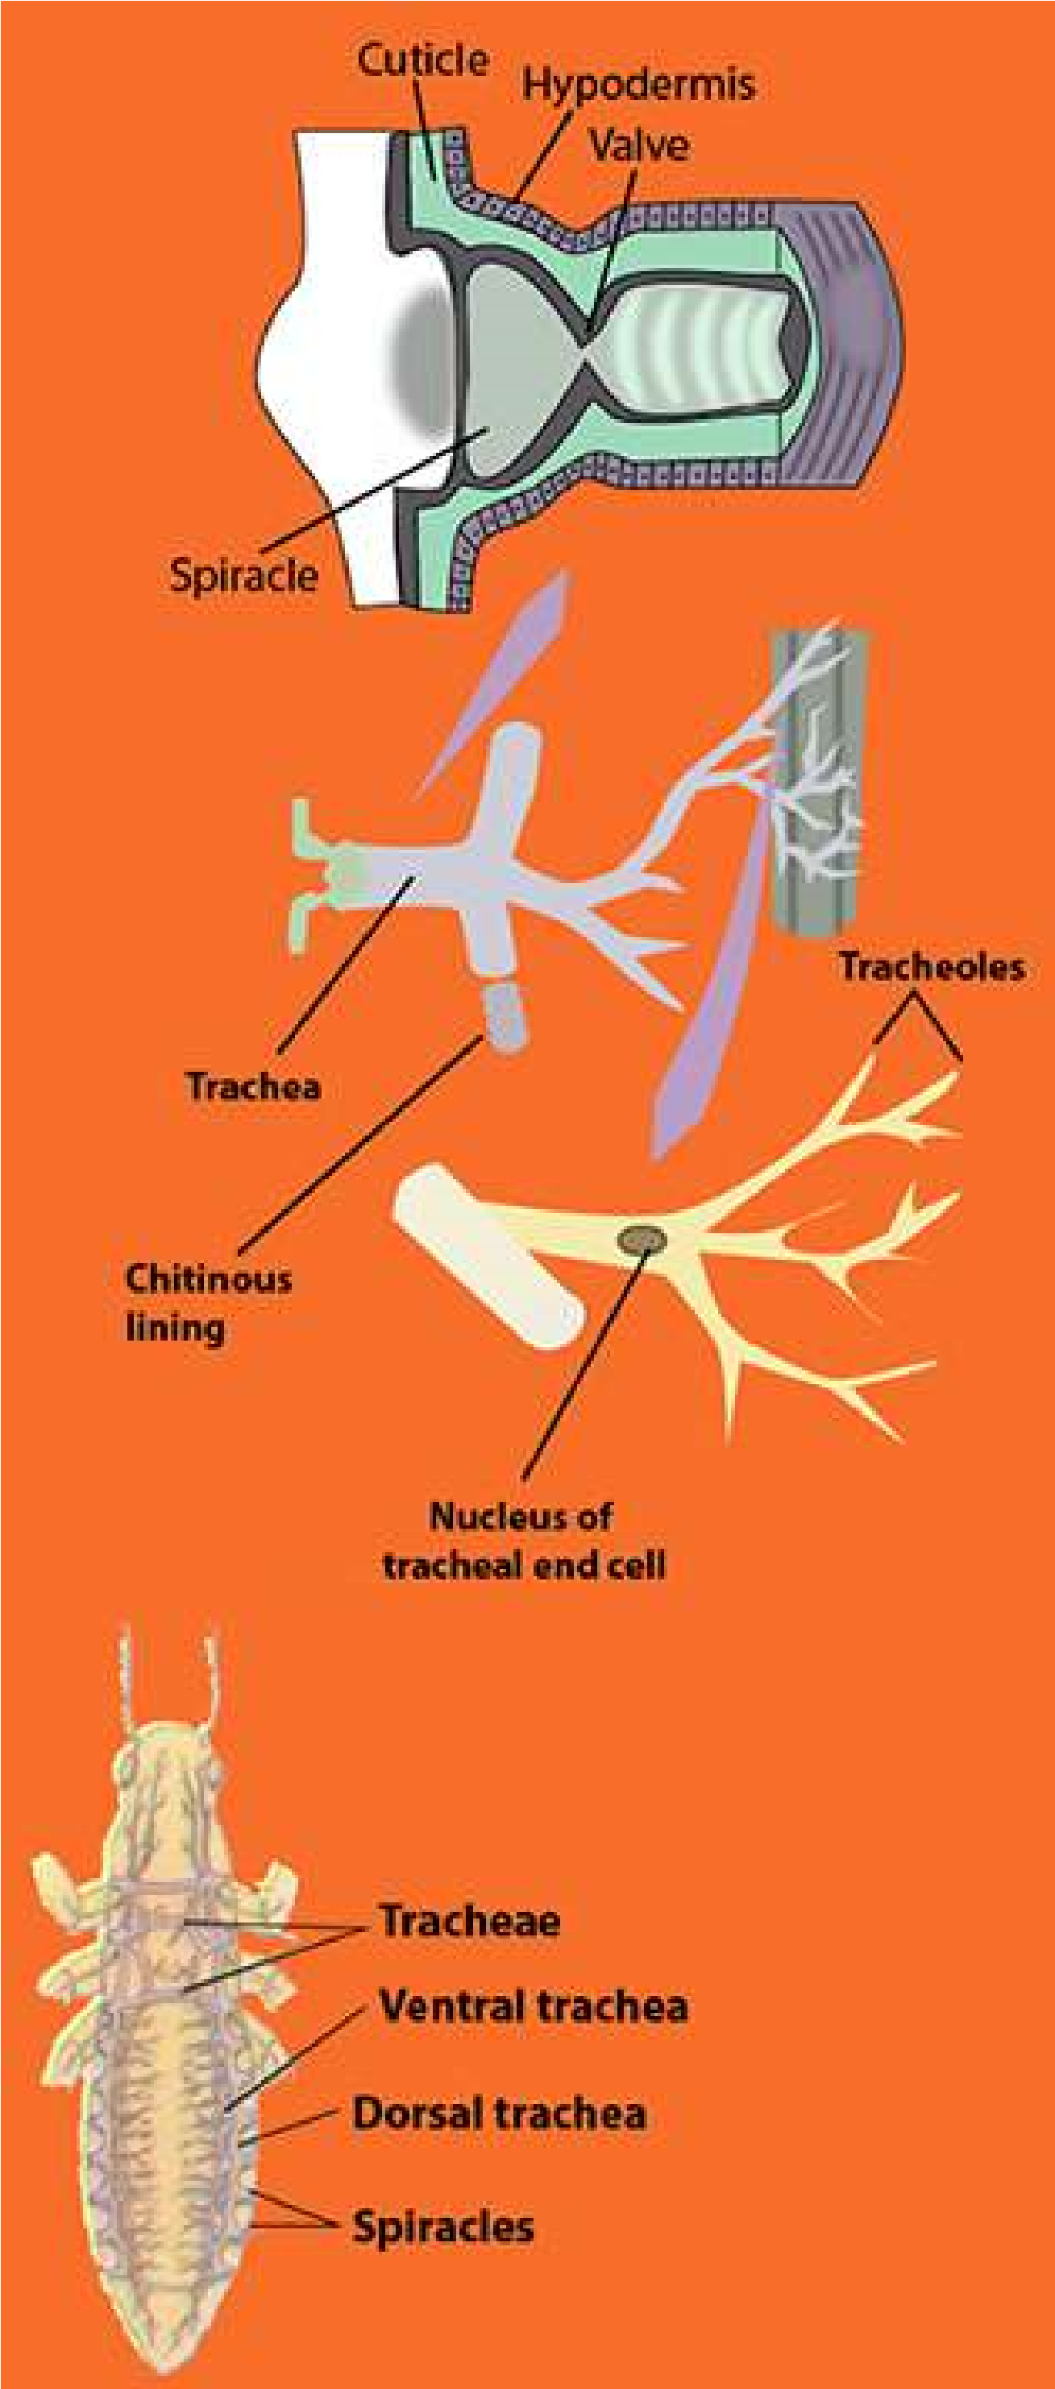Cockroach has specialized organs for respiration. The respiratory system of the cockroach is very specialized. It consists of branching systems of air tubules called tracheae lined by chitin. The main tracheal trunk communicates with exterior by 10 pairs of apertures called **spiracles**, present on the lateral sides of the body. Two pairs are in thorax while the rest eight are in each of the eight abdominal segments. The main tracheae divide and subdivide forming very ine thin-walled tubules called **tracheoles**. These tracheoles end into blind ducts partly illed with luid, in which the oxygen dissolves. These surround the organs and the tissues and directly supply oxygen to the living cells. A concentration gradient is set up between them and the spiracular openings and oxygen difuses into the trachea from the outside air. The movement of the air through the tracheal trunks transfers gases through inspiration and expiration. Air is pumped in and out of the tracheae by the expansion and contraction of the abdominal muscles (Dorsoventral muscles). When abdomen expands, the irst four pairs of spiracles open, air rushes in through these spiracles into tracheoles. Abdomen contracts, the anterior four pairs of spiracles close and posterior six pairs of spiracles open. This forces air through the tubes and eventually out of the body. In this way exhalation and inhalation take place. From the spiracles air enters into trachea and then tracheole, from where gaseous exchange between tissue cells and air in tracheole takes place. Thus air is directly supplied through tracheoles to the tissue cells. Blood is not involved in transport of gases(Fig.l3.4).

*Fig. 13.4 Respiration in Cockroach*

*Animation 13.5: COCKROACH*

*Source and Credit:* [*presentmam*](http://presentmam.blogspot.com/2013/08/cockroach-peripalanta-americana.html)

*Animation 13.6: Gas Exchange in Fish*

*Source and Credit:* [*s-cool.co.uk*](http://www.s-cool.co.uk/a-level/biology/gas-exchange/revise-it/gas-exchange-in-fish)

#### Respiration in ish

Fish respires through the gills which are paired structures present on either side of the body almost at the junction of head and trunk. Gills are most efective and highly modiied for gaseous exchange in aquatic animals. They are in four to ive pairs which may open through gill slits and are visible on the surface of the pharynx (cartilaginous ish) or are placed in bronchial cavities which are covered by **operculum**. Gills have great surface area for gaseous exchange. The gill surface is all the time ventilated by constant low of water. Heart pumps the blood directly to the gills from where oxygenated blood is carried to all the parts of the body. The deoxygenated blood from diferent parts of the body is received by heart. The heart of the ish is single circuit and the blood lows in only one direction. The blood enters the posterior side of heart and after passing through diferent chambers it is pumped into the gills. Water enters through the mouth and after passing over the gills move out of the body through the gill openings (Fig. 13.5)

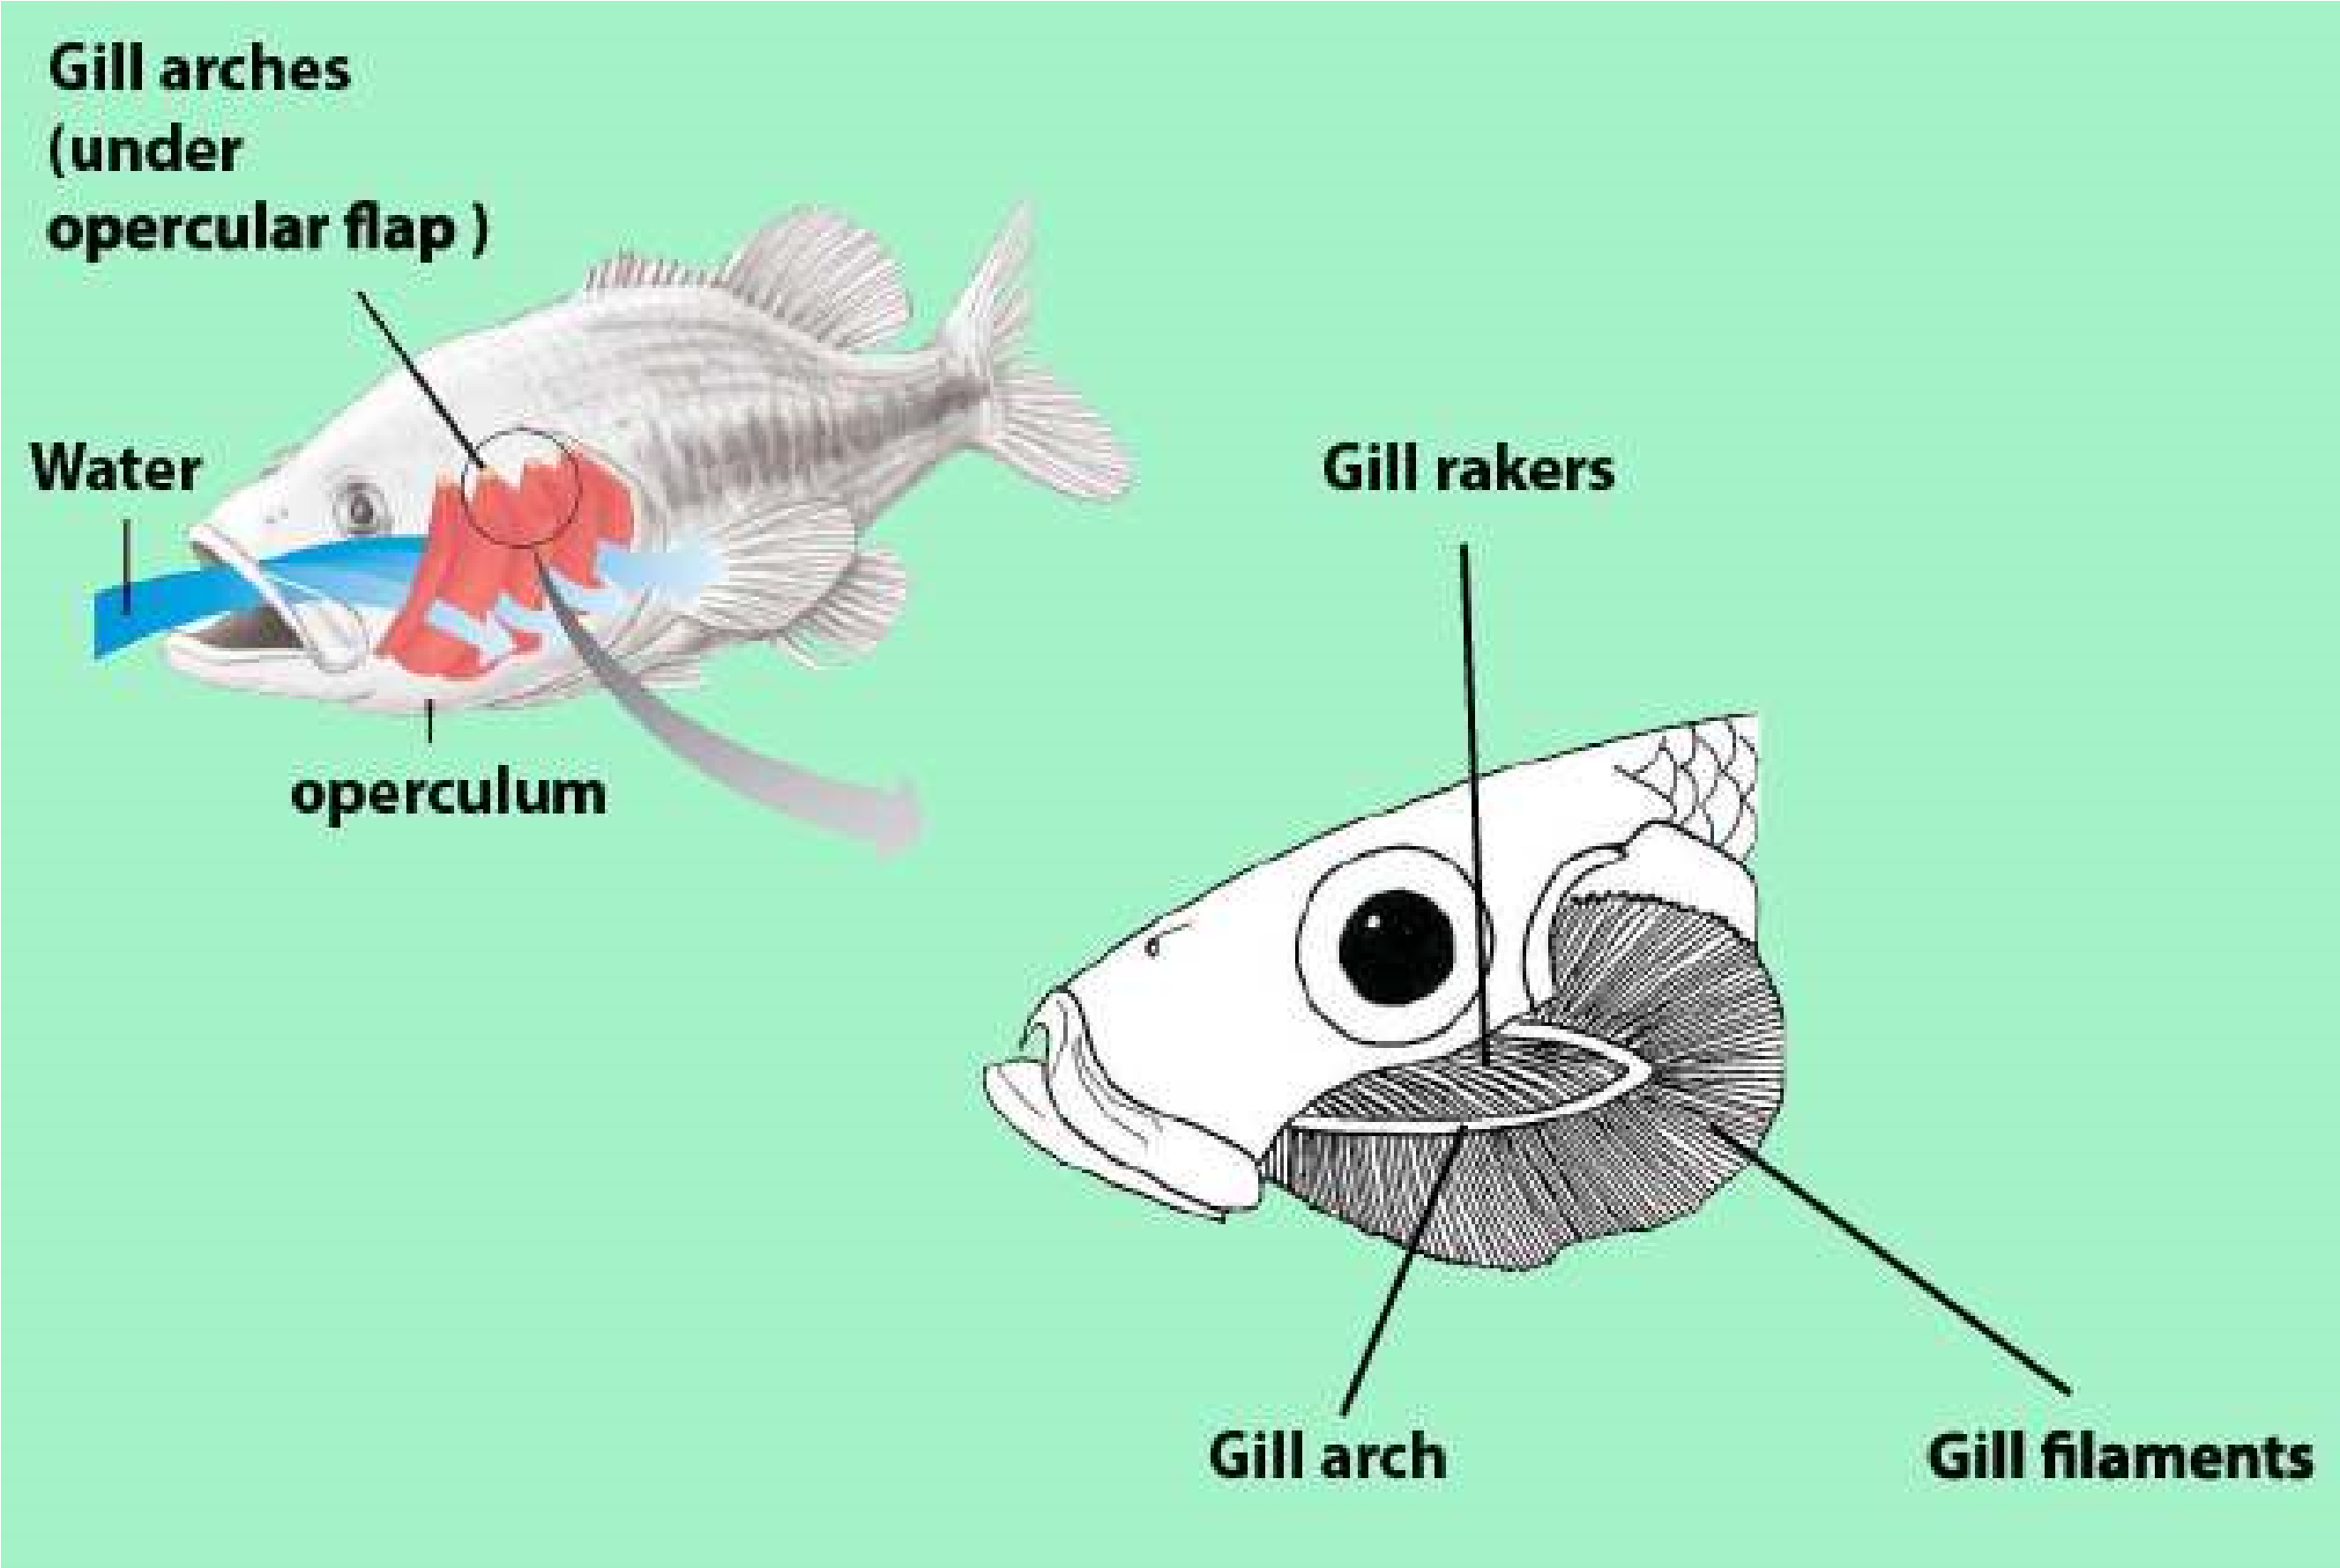

*Fig. 13.5 Water lows unidirectionally over the gills of a ish.*

##### Respiration in Frog

In frog, the gaseous exchange occurs through the lungs, by skin, and buccal chamber which are richly supplied with blood vessels. The gaseous exchange through the skin is known as cutaneous respiration.

Gaseous exchange through the lungs is called **pulmonary respiration**. In frog the air enters through the nostrils, when the nostrils are open; the mouth is closed. After entry of air the nostrils close, the loor of buccal cavity is raised, air is pushed into the lungs. This intake of air is known as **inhalation or inspiration**. Expiration occurs exactly in reverse order in sequence of inspiration.

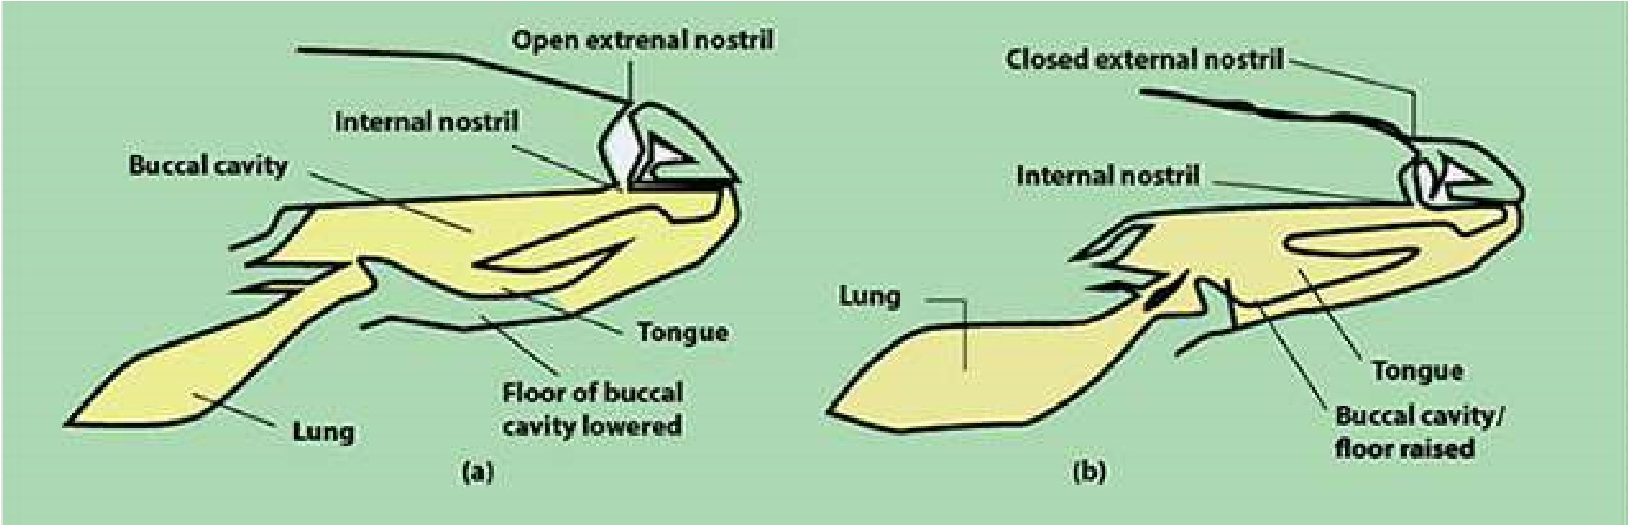

*Fig. 13.6 Two stages in inspiration (buccal respiration)*

*Animation 13.7: Respiration in Frog**Source and Credit: clipartbest*